RALEIGH 18” OFF-ROAD BIKE FOR SALE.

Needs tune-up: $250. If I have it tuned up, $200. If you do it.

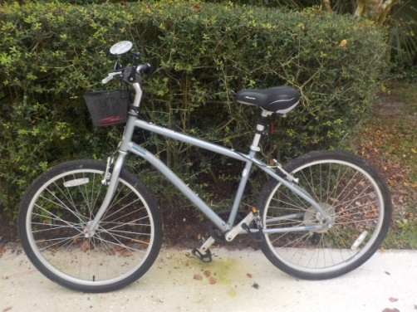

Contact Karelisa Hartigan [karelisa43@yahoo.com](mailto:karelisa43@yahoo.com)

