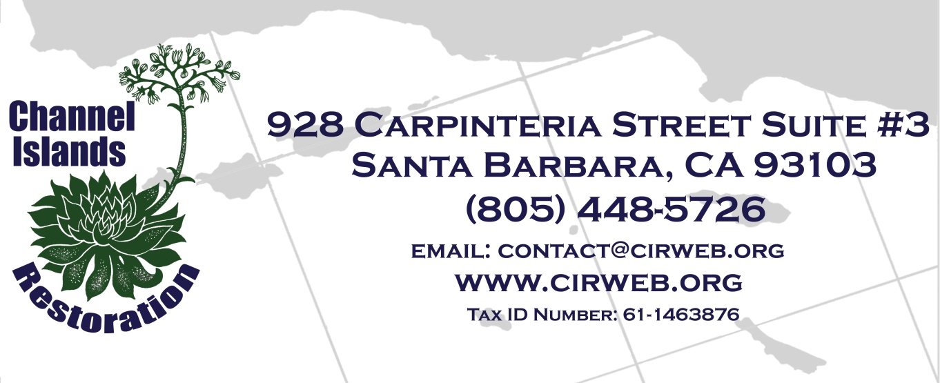

JOB OPENING
RESTORATION FIELD TECHNICIAN
SAN CLEMENTE ISLAND

TITLE: Restoration Field Technician
We anticipate hiring three highly qualified individuals.

POSITION LOCATION: San Clemente Island (a United States Navy Base).

TERM: This job is an on-call position and work will be provided on as-needed basis. We expect that the person who is hired will work during eight trips to the island. Each trip will be five days in length, approximately 40 hours per week. There will probably be one week of no work in between each trip, and the period of no work might be more than one week. The period of employment would be approximately from December 20, 2018 to May 30, 2020. It is possible (though not guaranteed) that other work on the island or in the San Diego area will become available during or after this time.

SUMMARY: The Field Technician weeds out non-native invasive species by carefully applying herbicides to selected non-native plants. Other weeding will be done by hand and with small hand tools. The job might also involve planting native plants, installing irrigation systems and other physical tasks as needed.

DUTIES AND RESPONSIBILITIES:
1. Conduct eradication and control of invasive plants at restoration sites. Utilize hand weeding, hand tools, power tools, herbicide application equipment such as spray bottles and backpacks.
2. Plant native plants.
3. Data collection and reporting using Global Positioning Systems (GPS units).
4. Perform other duties as directed by superiors.
5. Work collaboratively as a member of a cohesive team.

TRANSPORTATION, HOTEL AND FOOD
Free transportation will be provided to the island. Hotel accommodations and a daily food stipend will be provided while working on the island.

QUALIFICATION REQUIREMENTS:
Legal
- Must be a United States Citizen.
- Must possess a current Qualified Applicator Certificate (QAC) from the California Department of Pesticide Regulation.
- Must pass a background check by the Navy.

Experience
- Experience in the safe and effective application of herbicides required.
- Experience identifying invasive and native plants strongly preferred.

Other Requirements
- Must be willing to work with herbicides.
- Must be willing and able to commute to San Clemente Island and stay on the island four consecutive nights.
- Must be careful, conscientious and pay attention to detail, have a great work ethic, work efficiently, be enthusiastic, and above all be a positive functioning member of a diverse team.
- Must be able to work independently.

Physical demands
- Ability to work and hike outdoors in all weather conditions
- Ability to work long hours outdoors
- Ability to lift and/or move up to 30 pounds.
- Manual labor, hiking over steep, rugged terrain with frequently unstable rocky substrate while carrying hand tools and heavy backpack sprayers.
- Must be willing to wear appropriate safety gear such as coveralls, hiking boots, gloves, and goggles.

Work environment
Field conditions may be windy, hot, dusty, cold, muddy, and/or wet.

WAGES:
Starting at $17 per hour or higher, commensurate with qualifications and experience.

APPLY:
Submit cover letter and a résumé to jobs@cirweb.org. When you email your letter and résumé, please attach a scan of your QAC, proof of citizenship, and driver’s license.

CHANNEL ISLANDS RESTORATION
Channel Islands Restoration is a non-profit organization that restores habitat in unique natural areas on the Channel Islands and adjacent mainland. Learn more at www.cirweb.org

