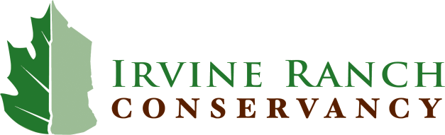

Job Opportunity – Field Crew Supervisor II

The Irvine Ranch Conservancy is a non-profit, non-advocacy organization with 50 full-time, part-time, and seasonal employees and nearly 400 volunteers. Our mission is to protect, restore, and enhance the natural resources of nearly 50,000 acres of protected open space on the Irvine Ranch Natural Landmarks in perpetuity, and to provide diverse opportunities for compatible public enjoyment through scientific, recreational, and educational initiatives and programs.

The Conservancy has an opening for a Field Crew Supervisor II who will assist in leading field crews and participates in implementing projects to restore native plant communities in degraded locations. The position performs a variety of technical and organizational tasks assisting the Science and Stewardship department in the preparation and implementation of landscape scale habitat restoration including, but not limited to: extensive weeding, both by hand and with herbicide, mowing with a variety of equipment, implementation of erosion control measures, seeding, planting, supplemental watering, and some ecological monitoring. The position may oversee the work of other field crew members and/or contract labor.

The successful candidate will possess the following:

- Education –Bachelor’s degree in ecology, plant science, horticulture, natural resource management or related field (or high school diploma and 4 years of related experience) and 2 years of work experience in land management.
- Experience
  - Knowledge of regional ecology, plant identification, plant taxonomy and regional environmental challenges.
  - Experience implementing restoration projects, use of mowers, weed eaters, back pack sprayers and GPS.
  - Experience managing irrigation systems (especially drip irrigation).
  - Experience performing ecological monitoring.
  - Current possession or willingness to obtain licenses or certifications such as first aid, CPR, herbicide application (e.g. Qualified Applicator’s License or Certificate), and all other training required for IRC field staff.
- Teamwork - Expected to interact with staff at all levels within the organization and partner organizations, including land owners, contractors, volunteers, and the community.
- Organization – Coordinates multiple diverse projects with several variables, sets realistic deadlines, and manages a timeline.
- Communication Skills – Clearly and accurately communicates ideas and objectives to others, provides information to assist workflow. Working Spanish competency (FSI 2+ or greater) highly desirable.
- Adaptability – Adapts or modifies processes or systems in response to changing circumstances.
- Problem Solving – Resolves routine problems; consults with senior staff or other team members to resolve unusual or complex problems.

Benefits: The Conservancy offers industry-leading benefits including paid holidays, vacation, and sick leave; medical insurance; dental and vision insurance; life and short- and long-term disability insurance; optional retirement plan with company match, HSA, FSA, dependent care plan, and optional long term care insurance.

How to Apply: Visit irconservancy.applicantpro.com to submit your resume and cover letter. Deadline is August 31, 2016 – Desired start date is October 3, 2016

The Irvine Ranch Conservancy is an Equal Opportunity Employer

