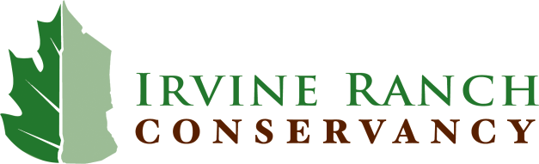

Job Opportunity – Project Manager -- Restoration

The Irvine Ranch Conservancy is a non-profit, non-advocacy organization with 50 full-time, part-time, and seasonal staff and nearly 400 volunteers. Our mission is to protect, restore, and enhance the natural resources of nearly 50,000 acres of protected open space on the Irvine Ranch Natural Landmarks in perpetuity, and to provide diverse opportunities for compatible public enjoyment through scientific, recreational, and educational initiatives and programs. We fundamentally believe that awareness and appreciation by the public, through making personal connections to the land, is essential to transforming the Irvine Ranch Natural Landmarks into an internationally acclaimed treasure of preserved open space and recreational enjoyment.

The Conservancy is now accepting applications for a Project Manager to be a part of a mission-based land management and stewardship organization. The person selected for this position will plan, oversee, coordinate, supervise and implement habitat restoration and resource management projects with the goal of achieving landscape-level effects. They will be responsible for execution of restoration activities as well as collection, management, and analysis of data, reporting writing and compliance with regulations and contract terms and conditions.

The successful candidate will demonstrate the following attributes:

- Teamwork - Effectively lead and work with staff. Collaborate with other projects using shared resources and knowledge.
- Organization –Manage and organize workflow, timelines, budgets and resources of multiple concurrent projects.
- Communication Skills – Actively and effectively interact with staff, contractors, volunteers, public agencies, landowners, and others.
- Adaptability – Adaptively manage projects under changing conditions, maintain flexibility in carrying out tasks, exercise good independent judgment.
- Problem Solving – Collaboratively and creatively solve problems.
- Education - Bachelor’s degree in natural resource management, biology, or related field.
- Experience
- Three (3) years work experience managing field projects and associated staff and contractors.
- Demonstrated experience and innovation in implementation of habitat restoration and resource management projects.
- Experience in the means and methods used in habitat restoration and related activities.
- Familiarity with the ecological systems and flora and fauna of the region.
- Using and supervising safe use and maintenance of a variety of field tools and equipment.
- License/Certification – Current driver’s license.

The ideal candidate will demonstrate the following attributes:

- Education – Master’s degree in natural resource management, biology or related field.
- Communication Skills – Spanish competency (FSI 2+or greater)
- Experience - Overseeing mitigation projects.
- License/Certification – Current possession of or willingness to obtain license or certification such as environmental survey and monitoring permits, first aid, CPR, Herbicide application, specialized equipment usage. 4WD experience a plus.

Salary: Highly Competitive FLSA Status: Regular, Full Time, Exempt

Benefits: The Conservancy offers industry-leading benefits including paid holidays, vacation, and sick leave; medical insurance; dental and vision insurance; life and short- and long-term disability insurance; optional retirement plan with company match, HSA, FSA, dependent care plan, and optional long term care insurance.

Working Condition/Physical Effort:
- Work requires physical exertion and/or strain to the point of physical fatigue. Work will include kneeling or squatting for extended periods of time.
- Ability to lift and transport up to 40 lbs.
- Ability to perform tasks in an open space setting that involves diverse weather conditions and demanding field circumstances of difficult and sometimes hazardous terrain.

How to Apply: Submit your resume, three professional references and a cover letter which includes your restoration implementation, project management experience and a list of tools and equipment you have used. Submit to jobs@irconservancy.org or fax to (714)731-7104. For complete job description visit our website at www.irconservancy.org Selected candidate(s) will be subject to a federal background check including motor vehicle record.

The Irvine Ranch Conservancy is an Equal Opportunity Employer

