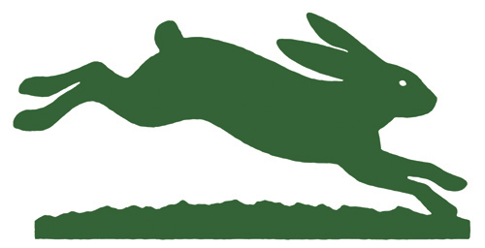


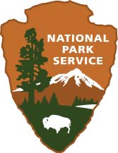
Trail Construction and Maintenance Internship
Are YOU excited to learn how build and maintain trails in the Golden Gate National Parks?
If so, join the crew!

The Golden Gate National Park’s Trail Crew and Park Stewardship program work with Trails Forever, a park wide initiative, to engage and sustain a vibrant community of stewards in the restoration of trails within the Golden Gate National Parks. With over 80,000 acres of parkland scattered throughout three counties, the Golden Gate National Recreation Area is a place that is both unique and fascinating, where trails play a vital role in the park visitor experience. Trail Construction and Maintenance Interns help maintain a world-class trail system, with the understanding that active engagement in the parklands leads to a deeper appreciation of their value.

Overview
Trail Construction and Maintenance Interns work with National Park Service Trail Crew and Golden Gate National Parks Conservancy staff by assisting in the construction and maintenance of park trails in Marin, San Francisco and San Mateo counties.

Terms
- Application deadline: open until filled
- Desired start date: a new round if interns usually begin in November and in May
- Length of position: 6 months
- Schedule: 40 hours per week, Monday – Thursday (4-ten hour days)
- Transportation provided to and from trails shop and housing in Marin

Description of Duties
- Assist park staff with the construction of erosion controlled structures, such as wood and rock retaining walls, steps/staircases, post and cable, split rail fences, and accessibility trails.
- Assist park staff with routine maintenance duties such as brushing trails with power equipment, clearing out water drains and outsloping to reduce erosion on trails.
- Keep and complete a detailed weekly work log of all projects and work accomplished in the field.
- Make safety a priority; responsible for use of personal protective gear and insuring that all tools, equipment, vehicles, and other co-workers are working safely.
- Follow instructions from park staff, understand and respect all park regulations and policies.
- Work with a professional attitude as part of a team.
- Attend, develop, and lead weekly safety meetings.

Desired Qualifications
- Familiarity and/or desire to learn how to operate tools to perform trail work such as: power drill, rock bar, single jack, shovel, rake, axe, brushing shears, weed trimmers, Pulaski and other trail maintenance tools.
- Aspiration to gain experience in trail maintenance and construction, including but not limited to: turnpikes, causeways, trail bridges, drainage dips, swales, installation of water bars, retaining walls, removal of brush and vegetation.
- Desire to learn natural and cultural history of Golden Gate National Recreation Area and the role of trails in protecting these resources.

Physical Requirements and Work Conditions
- Desire and ability to work outdoors for hours, at times in inclement weather and terrain. Willingness to perform strenuous physical activity such as frequent bending, lifting, and carrying heavy weights.
- Ability to work in inclement environments where exposure to poison oak and ticks are possible
- Indoor work is performed in a typical office setting
- Ability to lift, carry, and position objects weighing up to 50 pounds

Benefits
- Gain a working knowledge of trail construction and maintenance with a highly respected non-profit organization, with a model partnership between two Federal agencies.
- Opportunity to attend personal/professional development days to pursue an interest, including training and education opportunities in various departments within the National Park Service, The Presidio Trust and the Golden Gate National Parks Conservancy.
- Opportunity to develop a federal and non-profit resume
- Opportunity to live in and enjoy the scenery, wildlife and cultural resources of a spectacular National Park.
- Opportunities to work with staff and volunteers from diverse backgrounds that share a common interest in preserving and protecting our natural lands
- If eligible, opportunity to receive the Public Lands Corps Award upon completion of internship

Compensation
- Weekly out-of-pocket expenses of $150 per week is provided with dorm-style housing OR
$275 per week without housing.
- Dorm-style housing is provided in the Marin Headlands, just north of the Golden Gate Bridge

To Apply
- Please email your resume and thoughtful cover letter to Katie Teschler, Trail Stewardship Manager, at trails@parksconservancy.org

