For the best quality, customize and download the images in the accompanying PowerPoint.
- Go to insert – pictures to add your own logo (add to the blank white space by the Falls Free Wisconsin logo).
- Go to insert – text box to add additional local information (add to the blank white space by the Falls Free Wisconsin logo).
- To save as an image, to go file -> save as, choose the folder to save in and click “JPEG” or “PNG” under the “Save as type:” drop down.
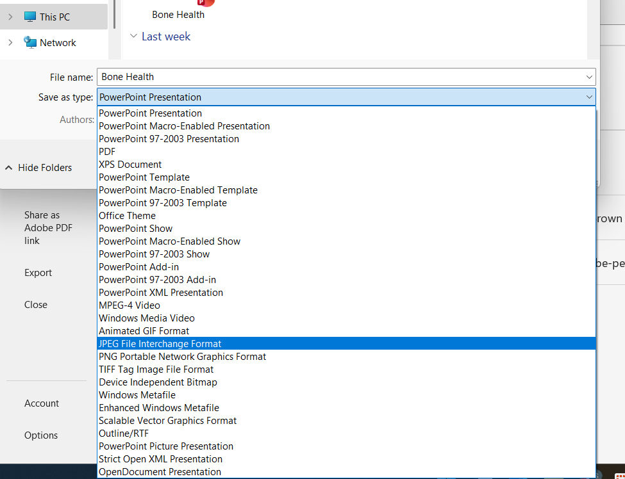

Asset | Suggested Message for Social Media
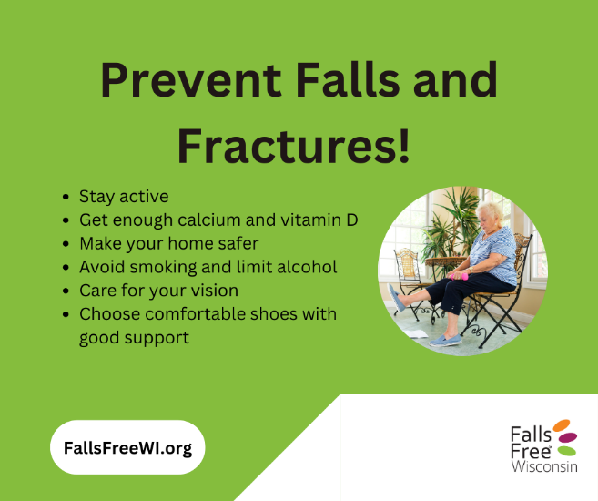 | Having strong and healthy bones is important as we age. By taking some simple steps, we can reduce the risk of falls and bone fractures to enjoy a safer, more confident lifestyle.  Weaker bones break more easily—sometimes slowly over time, or suddenly after a fall. Once one fracture happens, the chance of another goes up.  Learn more about bone health from the Bone Health & Osteoporosis Foundation at AmericanBoneHealth.org/density and use the Fracture Risk Calculator to find your risk: AmericanBoneHealth.org/ncoafrc.  Find tips to improve your bone health and stay #FallsFree at FallsFreeWI.org. #FallsFreeWI #BoneHealth
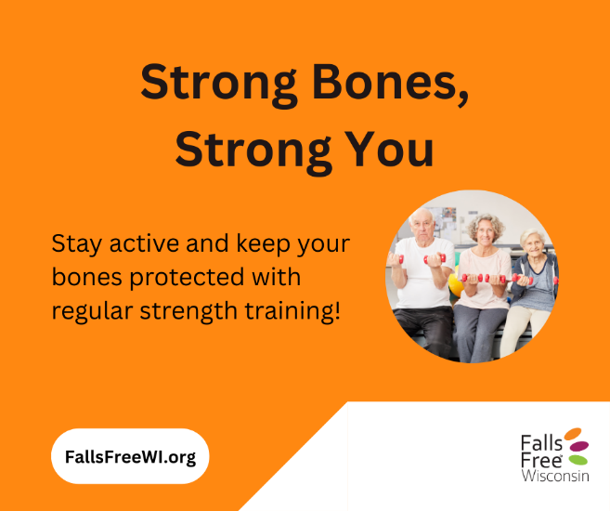 | Do regular strength exercises to stimulate bone-building cells and increase bone health and density and practice balance exercises to reduce the risk of falls!  Osteoporosis, a disease that causes bones to lose density and strength over time, and muscle weakness are closely connected, and inactivity can further increase the risk of falls, fractures, and loss of balance. The risk increases as we age and is more common in women.  Find some simple exercises to practice and stay #FallsFree at FallsFreeWI.org/balance-strength. #FallsFreeWI #BoneHealth
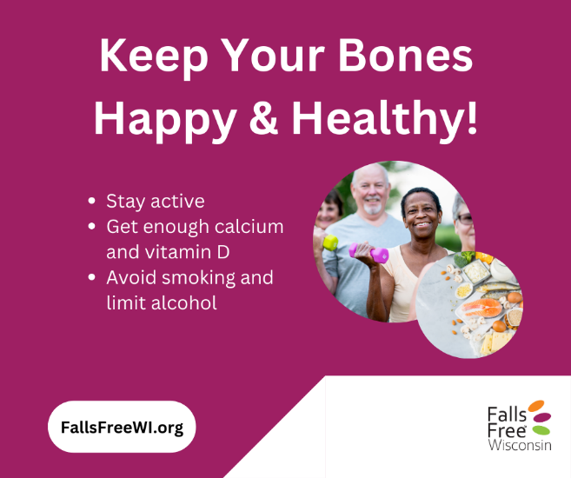 | Strong bones and steady muscles work together to keep us moving with confidence as we age. But when bone strength decreases and muscle mass declines, everyday activities can become more challenging — and the risk of falls and fractures increases.  The good news? Small, consistent habits can make a big impact. Staying active, eating calcium- and vitamin D–rich foods, and doing simple strength and balance exercises all help protect your bones and support long-term mobility.  Take charge of your bone health, understand your risks, and find steps you can take today to stay steady #FallsFree at FallsFreeWI.org. #FallsFreeWI #BoneHealth

