  LUNCH & LEARN  Know Your Voting Rights Zoom Webinar  Sept. 9, 2025 | 11:30 – 12:30 p.m.  Celebrate Disability Voting Rights Week by joining us for a panel discussion. Panelists include a clerk, poll worker, self-advocate,  and an expert on guardianship. We’ll discuss:  - Your voting rights  - Basics of voting and guardianship, and how to get your voting rights back  - Personal stories from voters with disabilities  - What to do if you have a problem at the polls, and more!  Intended Audience: municipal clerks, people with disabilities, caregivers, service providers, municipal and county clerks, elected and appointed officials,  and media.  Register at: bit.ly/DisabilityVotingRightsWeek  Or scan the QR code:  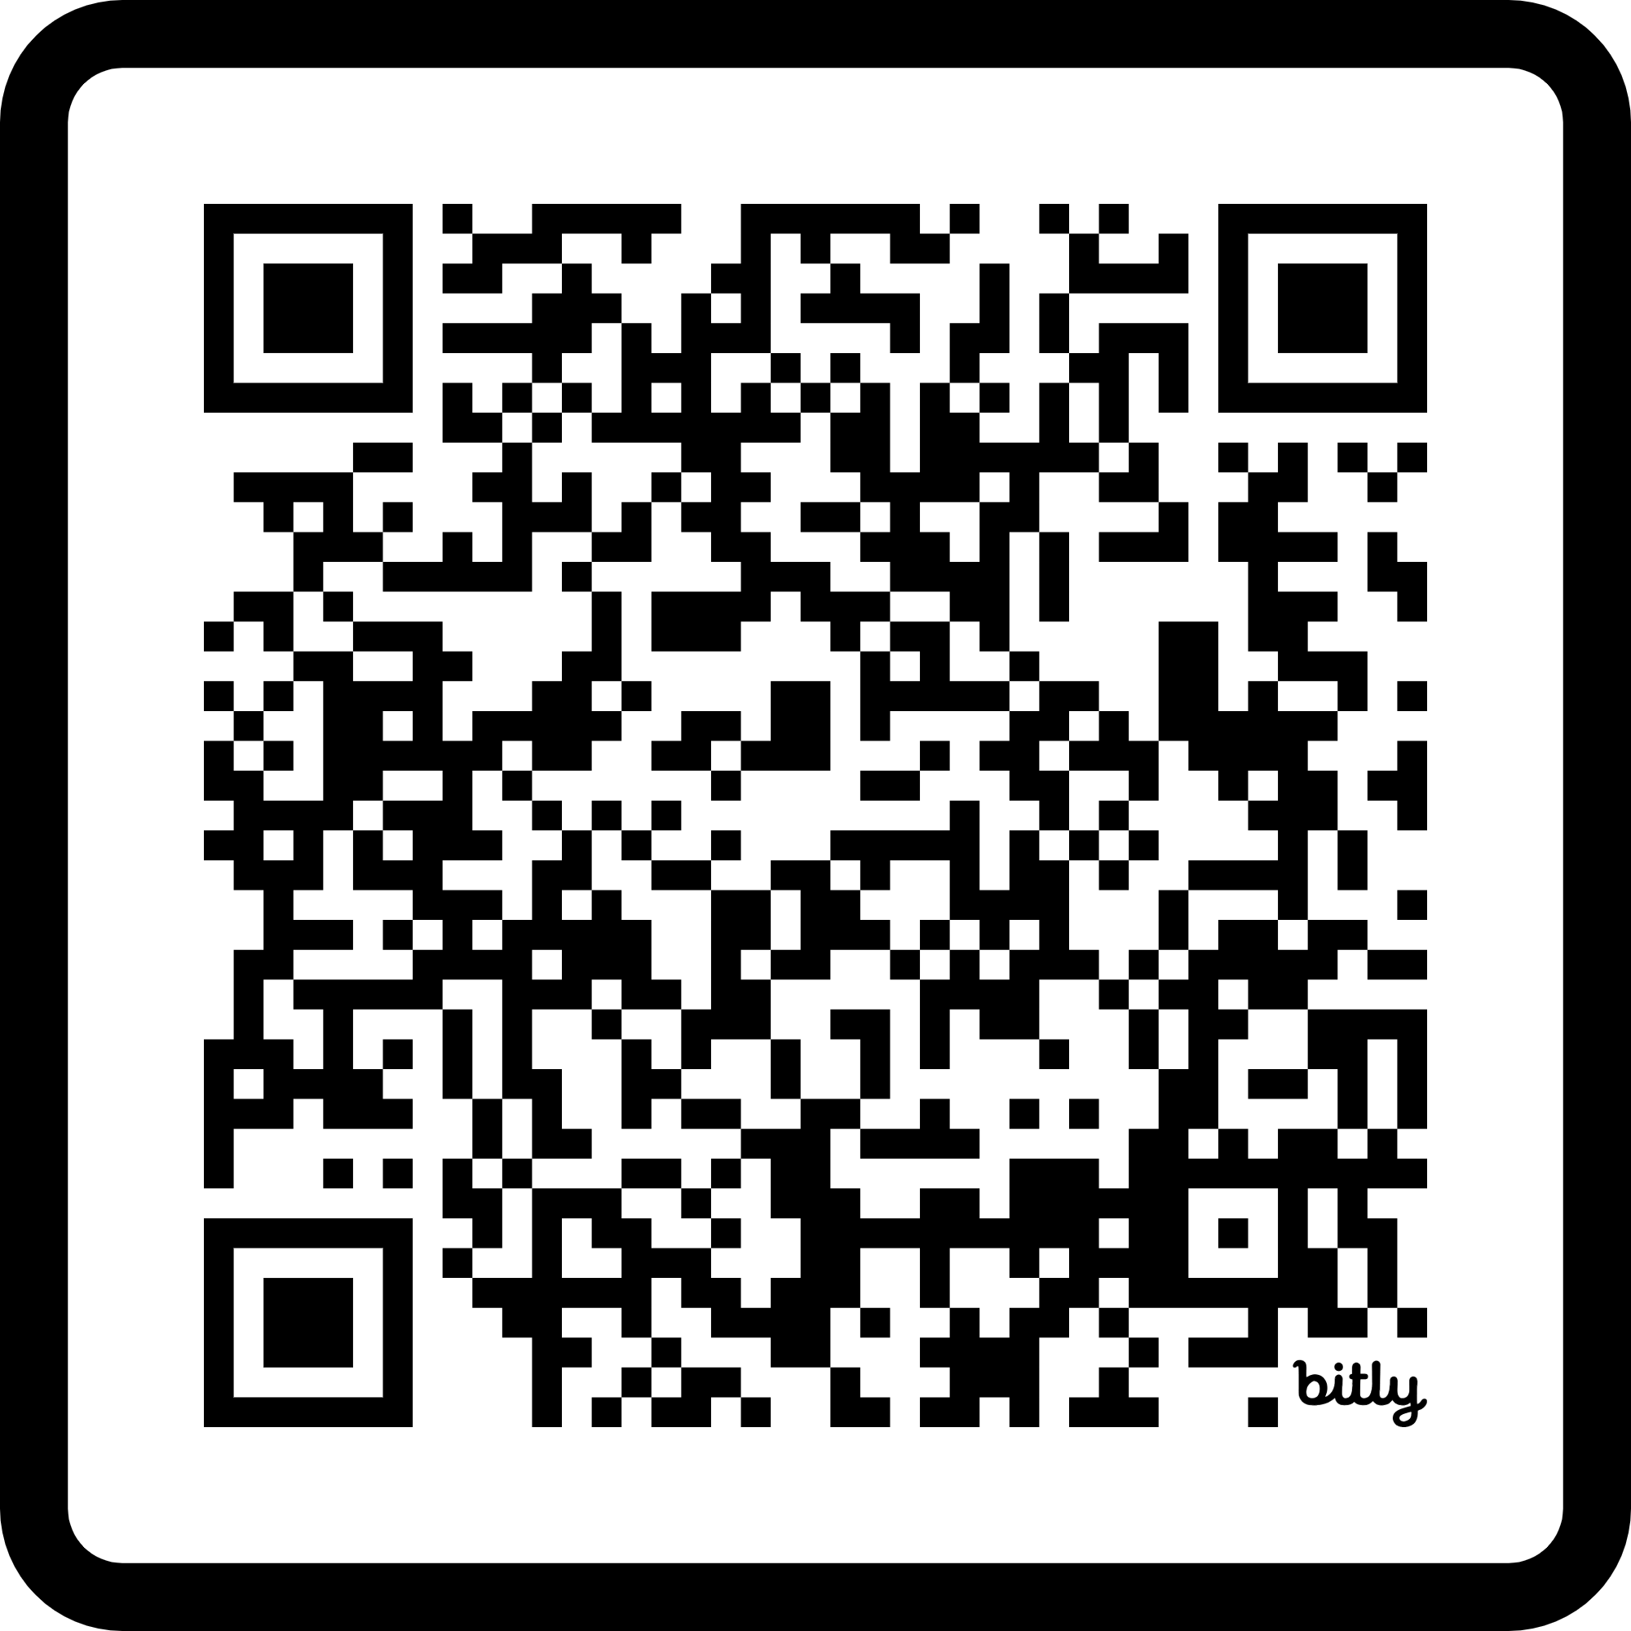
  ASL Interpreters will be available.
  To request additional accommodations, please register as soon as possible and include that in your request.
  Send questions
  in advance to
  info@disabilityvote.org
  www.disabilityvote.org
  Need help
  with voting?
  Contact the Disability Rights Wisconsin
  Voter Hotline at:
  844-DIS-VOTE /
  844-347-8683
  or email us at
  info@disabilityvote.org

