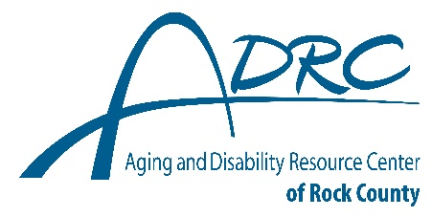
1717 Center Avenue, Janesville

FOR IMMEDIATE RELEASE

Contact: Karen Tennyson, Dementia Care Specialist, ADRC of Rock County
608.921.7165 or karen.tennyson@co.rock.wi.us

Limited space still available
Virtual Caregiver Class
Stress-Busting Program for Family Caregivers of People with Dementia
Wednesday September 3 – October 29, 2025 5:30-7pm

Registration is required by August 25th, 2025.

The Aging & Disability Resource Centers of Rock, Green, Grant, Iowa & Lafayette Counties are offering the 9-week Stress-Busting for Family Caregivers of People with Dementia virtual class as developed at the University of Texas Health Science Center by Sharon Lewis and the WellMed Charitable Foundation beginning Wednesday, September 3rd.

Who is SBP for? Anyone caring for someone with a form of dementia will benefit from the program. What is SBP? The Stress-Busting Program for Family Caregivers of People with Dementia is a proven curriculum developed by Sharon L. Lewis, RN, PhD, FAAN in conjunction with the University of Texas Health Science Center and the WellMed Charitable Foundation which teaches stress management, relaxation tools, coping strategies and problem-solving skills with a support group component. Participates view the program as a source of strength and support for their caregiving role.

“Caregivers of someone with dementia experience high levels of stress, anxiety and depression. Dealing with those issues in a healthy way is vital to a caregiver’s well-being. Consequently, to care for the person with dementia, the caregiver must first learn how to care for themselves.”, said Karen Tennyson dementia care specialist at the Aging and Disability Resource Center of Rock County.

Reserve your spot today for the Stress-Busting Program for Family Caregivers of People with Dementia by contacting Rock County - Karen Tennyson 608/921-7165, Green or Iowa Counties Bonnie 608/426-4295, Grant or Lafayette Counties call Hailey 608/426-0185.

