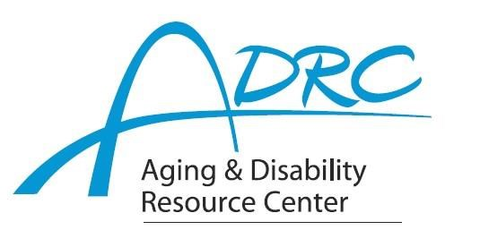

Of Rock County

**1717 Center Avenue, Janesville**

**September 16, 2024**

**FOR IMMEDIATE RELEASE**

Contact: Karen Tennyson, Dementia Care Specialist, ADRC of Rock County

608.741.3615 or karen.tennyson@co.rock.wi.us

**You are cordially invited to**

**A Day at the Club – A Caregivers Retreat**

**Please Join Us for this Complimentary Event**

**Wednesday, November 6th from 9am-4pm**

**to Honor Family Caregivers**

**The ADRCs of Jefferson, Rock & Dane Counties are pleased to host**

**A day of pampering and information for family caregivers**

On Wednesday, November 6, 2024 The Aging & Disability Resource Centers of Jefferson, Rock & Dane Counties will host a day to honor family caregivers at The Fort Atkinson Club – 211 S. Water Street E, Fort Atkinson, WI.

The day starts with a variety of spa and relaxation services. Lunch is included and will be followed by an afternoon of informative conversation about a variety of topics related to caring for someone with dementia including safety, security, technology, research and perspectives from a family caregiver and person with a dementia diagnosis.

Full and half day sessions are available to meet scheduling needs. Respite care for your family member is available based on need and with a prior registration for services. This is a complimentary event. **Preregistration is required. Please contact Karen Tennyson at 608/741-3615 for more information and to complete a registration.**

For more information on the dementia care specialist program and services available, please contact your local Aging & Disability Resource Center.

####