**Wednesday, June 5, 2024 is Wisconsin Heat Awareness Day – for more information see:**

[**Weather Safety - Heat**](https://www.weather.gov/safety/heat) **<**<https://www.weather.gov/safety/heat>**>**

**Facebook link for the attached image:** <<https://www.facebook.com/photo/?fbid=853295303505828&set=a.242149414620423>>

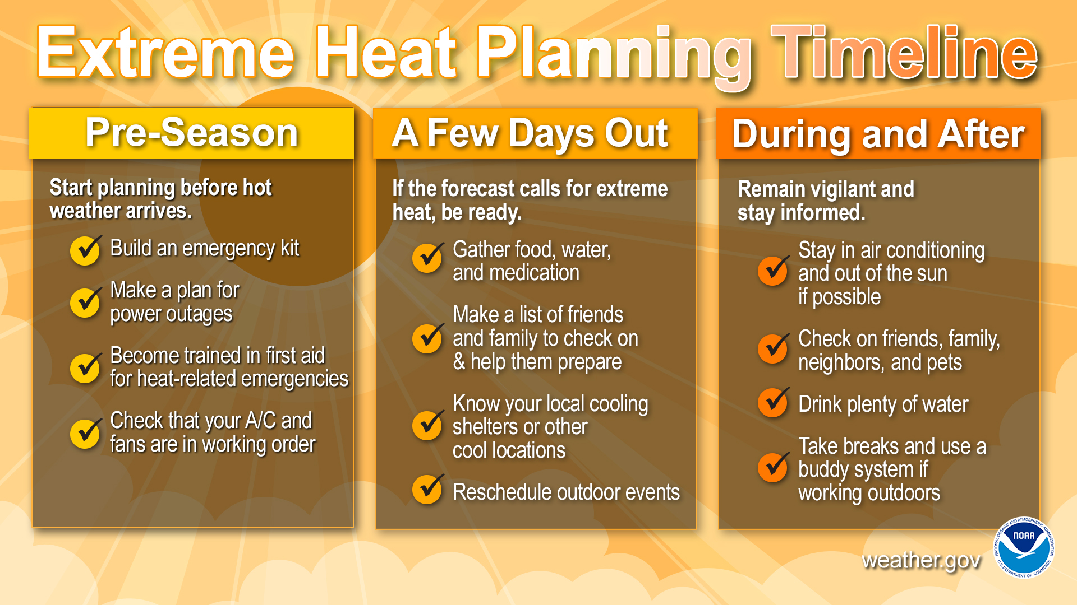

(courtesy of GWAAR/jfm)