 **­­­­­**

**Developed at**

**Who**: Family caregivers of a loved one with dementia

**What**: Multi-component program meets

* 90 minutes/ week for 9 weeks
* Groups of up to 8 people

**Where:** Virtual Class via Microsoft TEAMs

**When:** Monday September 25 – November 20, 2023 from 2-3:30pm

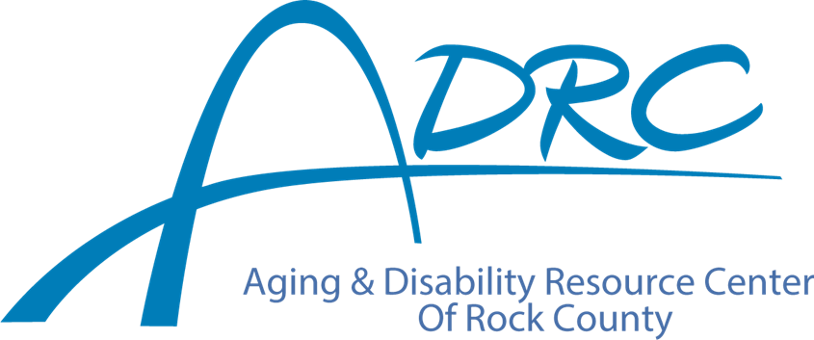

**Do you provide care for a loved one with Alzheimer’s disease or other form of dementia?**

***You Are Not Alone***

* This program will teach:
  + stress management techniques
  + relaxation and coping strategies
* Program available at no cost to Rock County residents

**Information**

**Program for Family Caregivers of People with Dementia**

**Facilitated by the ADRCs of Rock & Marquette Counties**

**Please call for more information or to register:**

**Call Karen Tennyson 608/741-3615**

**(**