**Contact: Allison Kodeih, Program Director**

**Organization:** The Remember Project

**Email Address:** akodeih@rememberproject.org

**Phone Number:** 651.251.5771

August 2, 2021

**\*\*\*PRESS RELEASE\*\*\***

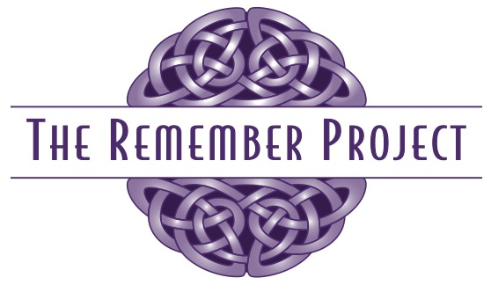

Applications Open for Arts & Aging Partnership

Wisconsin continues to lead the way in creating Aging in Place initiatives for older adults. The artists involved with The Remember Project are now offering distance-learning workshops for professionals and volunteers in the field of Aging. There is no registration fee thanks to a generous grant from Bader Philanthropies and applications are due on August 20th. Priority focus are the ADRC regions of southwest Wisconsin (including the counties of Buffalo, Crawford, Jackson, Juneau, LaCrosse, Monroe, Pepin, Richland, Sauk, Trempealeau, and Vernon), and the ADRC regions of east central Wisconsin (including the counties of Adams, Calumet, Fond du Lac, Green Lake, Marquette, Outagamie, Waupaca, Waushara, and Winnebago). However, applications from throughout the state are welcome at this time.

The ultimate goal of the Remember Project ([www.rememberproject.org](http://www.rememberproject.org)) is to assist community members and leaders consider new ways to think about memory loss and to become aware of local resources that support families who are dealing with a diagnosis of dementia or Alzheimer’s disease. This program takes a unique approach to building awareness, sharing information, and inviting authentic community conversations.

“We are launching our Wisconsin distance-learning professional opportunity in September,” said Remember Project Founder, Danette McCarthy, “and we are excited to help communities grow stronger in their use of the arts to reduce the fear, stigma, and isolation associated with memory loss.”

The Arts & Aging Partnership is created within a framework of strengthening the relationships and connections between artists and those who work or volunteer in the field of Aging. The workshops use the art forms of theatre, music, movement, storytelling, and visual art for exploratory learning and conversation. Participants will join a cohort of learners who work together for about 5 months and experience six learning modules. Each module includes independent pre-work guided by pre-recorded videos, a virtual meeting to discuss pre-work and learn about successful arts partnerships, and a reflection activity to wrap up the module.

The arts are a powerful tool in helping older adults be recognized as valued community members, enabled to stay active and independent as long as possible. Far too often, incorporating the arts into service goals & outcomes can feel mysterious, alienating or cumbersome to those who have not had this training or experience. The Arts & Aging Partnership sets the stage for new ways of thinking about arts partnerships that support service goals.

“Our ultimate goal,” said Program Director, Allison Kodeih, “is to support those who provide services to older adults who may lack access or have barriers to creative opportunities. Thriving through engagement in the arts and creating community connection --- while reducing isolation --- is key to living full lives as we grow older.”

Learn more and apply to participate in the first Wisconsin Arts & Aging Partnership Cohort by going to the Coming Up page of The Remember Project website ([www.rememberproject.org](http://www.rememberproject.org)) or by reaching Program Director Allison Kodeih at [akodeih@rememberproject.org](mailto:akodeih@rememberproject.org). You can also reach Allison or other Remember Project artists at 651.251.5771. Applications are due on August 20th for this cohort of learners.

**## 08.02.2021##**

**Photo:** The arts provide engaging activities for the body, mind, and spirit for a vibrant elderhood.