|  |  |  |
| --- | --- | --- |
|  | | |
| Wisconsin Senior Community Services Employment Program State Plan  Program Years 2020–2023 | | |
|  | Wisconsin Department of Health Services Division of Public Health | P-00409 (03/2020) |

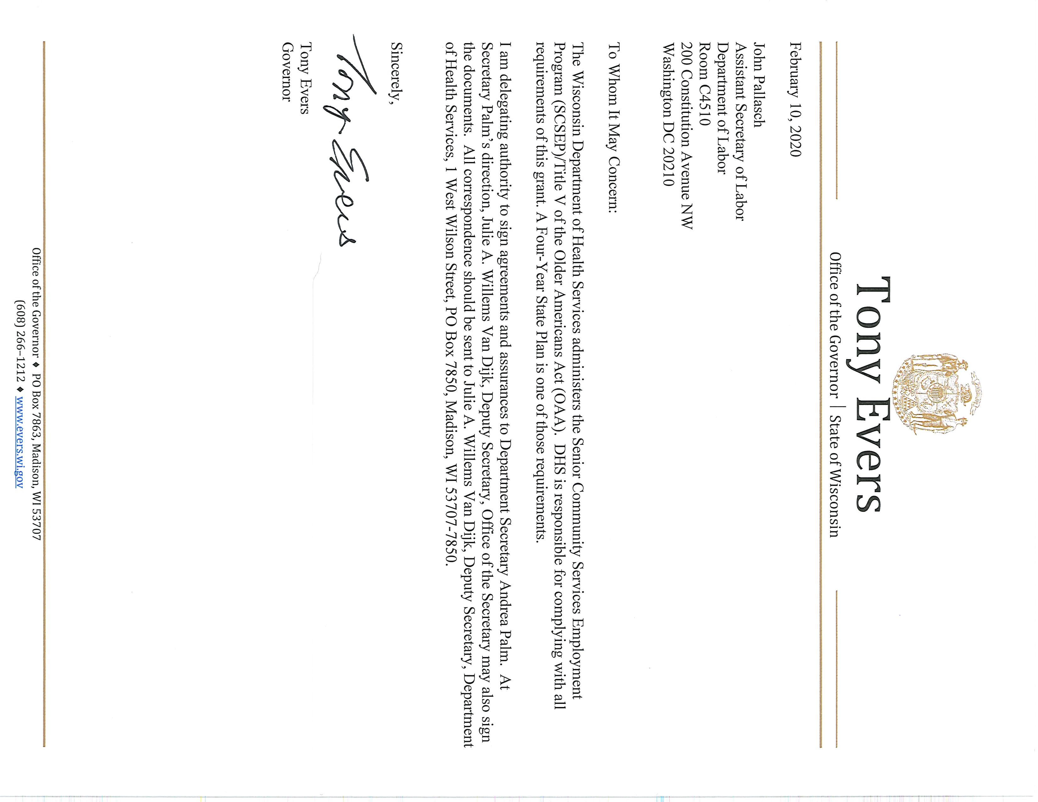

# Program Administration Designee and Plan Signature

Name of Title V of the Older Americans Act Grant Recipient/Lead Agency:  
Department of Health Service, Bureau of Aging & Disability Resources  
Laura M. Langer, Senior Employment Program Coordinator  
Address: 1 W. Wilson St., Rm. 551  
 Madison, WI 53707  
Telephone Number: (608) 267-9097  
Facsimile Number: (608) 267-3203  
E-mail Address: [laura.langer@dhs.wisconsin.gov](mailto:laura.langer@dhs.wisconsin.gov)

Name and Title of State Senior Community Service Employment Program   
Administrator (Signatory Official):   
Julie A. Willems Van Dijk, Deputy Secretary  
Address: 1 W. Wilson St., Rm. 650  
 Madison, WI 53707  
Telephone Number: (608) 266-8399  
E-mail Address: [dhsgrantreview@dhs.wisconsin.gov](mailto:Julie.willemsvandijk@dhs.wisconsin.gov)

I certify that for the State of Wisconsin, the agency and official designated above have been duly designated by Governor Tony Evers to represent the State in the capacities indicated for the Senior Community Service Employment program. Later changes in the designation of officials will be provided to the U.S. Department of Labor as such changes occur.

I further certify that we will operate our Senior Community Service Employment programs in accordance with this Plan and the assurances herein.

Signature: Date:

# Table of Contents

State Plan Purpose 1

Plan Involvement of Organizations and Individuals 2

Solicitation and Collection of Public Comments 3

I. Economic Projections and Impact 3

A. Employment Opportunities for Older Workers 4

B. Unsubsidized Job Training and Skills 5

C. Projected Employment Opportunities 6

II. Service Delivery and Coordination 8

A. Actions Taken to Coordinate SCSEP with Other Programs 8

B. Long-Term Strategy for Engaging Employers 14

C. Long-Term Strategy for Serving Minority Older Individuals 15

D. List of Needed Community Services and Places that Need Them Most 19

E. Long-Term Strategy to Improve SCSEP Services 20

F. Strategy for Continuous Improvement 22

III. Location and Population Served: Basic Distribution of SCSEP Positions 22

A. Localities and Populations for Which Projects are Most Needed 22

B. Cities and Counties Where the SCSEP Project will Take Place 24

C. Slot Imbalances and Steps to Correct Inequities 26

D. Long-Term Strategy for Equitable Distribution of SCSEP Positions 34

E. Ratio of Eligible Individuals per Service Area 37

F. Relative Distribution of Eligible Individuals 39

G. Steps Taken to Avoid Service Disruptions 57

Appendices 57

Appendix A: State and National Authorized Positions 58

Appendix B: Wisconsin Workforce Development Boards and Areas 60

Appendix C: Wisconsin’s Aging and Disability Resource Centers 61

Appendix D: Wisconsin State Strategic Plan 2020-2023 Meeting Notice 63

Appendix E: National Grantee Comments 65

Appendix F: Public Comments 66

# State Plan Purpose

The Wisconsin Senior Community Services Employment Program (SCSEP) is committed to improving the employment of older adults through valuable community service and work experience training with local nonprofit and government agencies.

The Older Americans Act (OAA), as amended in 2016, provides for the delivery of services to older adults that support their desire to live independently and be self-sufficient. For those seeking employment, the choice is the Senior Community Services Employment Program (SCSEP). The program promotes useful part-time opportunities in community service activities for unemployed, low-income adults who are age 55 or older, have a total family income of less than 125% of the federal poverty level, and have poor employment prospects. The SCSEP objective is to increase the number of people who can benefit from unsubsidized employment in the public and private sectors.

Older, experienced workers are a valuable asset to Wisconsin’s workforce. The purpose of the Wisconsin Senior Community Services Employment Program State Plan (hereafter referred to as the SCSEP State Plan) is to serve as a blueprint for SCSEP grantees and subrecipients who meet regularly to discuss ideas, listen to concerns, and share the same vision of providing support and training for older people.

The SCSEP State Plan is a stand-alone document. The U.S. Department of Labor issued a Training and Employment Guidance Letter (TEGL 7-19) on December 31, 2019, for Program Year (PY) 2020–2023 Workforce Innovation and Opportunities Act (WIOA) Unified or Combined State Plan Instructions. SCSEP is a required partner through WIOA.

This plan provides useful information on demographics; labor market projections; community service; employer outreach; and coordination with the Wisconsin Department of Workforce Development, Older Americans Act programs, and other partner agencies. The information contained within this plan provides a shared understanding of the workforce issues encountered by older adults, so that grantees and subrecipients can plan coordinated activities that are effective, efficient, and positive. The SCSEP grantees are committed to assisting older workers and employers in achieving their workforce potential and sharing an interest in producing a vibrant future economy.

# Plan Involvement of Organizations and Individuals

The Older Americans Act, as amended in 2006, stipulates that the state plan must describe the process used for ensuring that various organizations and individuals are involved, and that their advice and recommendations are sought.

The Wisconsin Department of Health Services (DHS), Bureau of Aging and Disability Resources (BADR) administers the SCSEP as the state grantee and is responsible for the development of the SCSEP State Plan.

On Thursday, February 20, 2020, a public meeting was held in Madison, Wisconsin at the Greater Wisconsin Agency on Aging Resources office. The following stakeholders were invited to participate in the meeting and/or submit information for the SCSEP State Plan:

* State grantee: Wisconsin Department of Health Services, Division of Public Health, Bureau of Aging and Disability Resources, Office on Aging
* State subrecipients:
  + Greater Wisconsin Agency on Aging Resources, Inc.
  + Fox Valley Workforce Development Board, Inc.
  + Southwestern Wisconsin Workforce Development Board, Inc.
  + Workforce Connections, Inc.
* National grantees:
  + National Indian Council on Aging, Inc. (set-aside grantee) (NICOA)
  + Senior Service America, Inc. (SSA)
  + SER-Jobs for Progress, Inc. (SER)
* Other invitees:
  + WorkSmart Network
  + Employment & Training Association, Inc.
  + Wisconsin Department of Workforce Development

The State of Wisconsin SCSEP Administrator spoke with the Department of Workforce Development representative prior to plan development to discuss coordination of a partnership between the SCSEP and WIOA. The PY 2020–2023 WIOA Combined State Plan can be found at: <http://www.wi-cwi.org/resources.htm>.

Included in this plan are comments pertaining to some sections of the SCSEP State Plan that national grantees submitted with their recommendations for the PY 2020–2023 State Stand Alone Plan.

# Solicitation and Collection of Public Comments

BADR distributed plan recommendations via email to partners and stakeholders for feedback, and invited them to participate in the SCSEP State Plan meeting.

The meeting was held with state subrecipients and national grantees to review and address issues about the equitable distribution report, job center collaborations, marketing and recruitment techniques, and services for rural and minority populations. The Workforce Development Board members, county job centers and job service partners, area agencies on aging, county aging units, and aging and disability resource centers (ADRCs) were also invited to attend this meeting.

A copy of the SCSEP State Plan was also distributed for comment through the listserv known as “BadgerAginglist,” which comprises individuals representing aging and other interested organizations in Wisconsin, as well as some national and international groups.

See appendices for comments submitted prior to and after submittal of the final plan.

# Economic Projections and Impact

The SCSEP assists participants in obtaining the skills necessary to become marketable in today’s changing workforce. The assessment process works on creating and building employment opportunities for people who may or may not have worked, obtained education at differing levels, or encountered both personal and work barriers. Labor market information through Job Center of Wisconsin, WisConomy, and the U.S. Department of Labor’s O*Net is used to help participants select the best occupation and understand the knowledge and skills needed. An important, required instrument used in developing a plan of action for the participant is the Individual Employability Plan (IEP). The IEP is the essential employment roadmap to success. It determines the participant’s training needs to learn or enhance new skills and establishes a timeline to meet goals and achieve success.

Researching and understanding labor market information is an integral part of learning key industries that are appropriate for older workers. The strategy is to guide participant toward high growth industries. However, this is often not suitable for the people served through the SCSEP. Many participants find it difficult to obtain employment and are often discouraged by employers when applying for a job. Because participants usually prefer part-time versus full-time employment, employers often shy away from hiring older adults, whose work time may be limited, compared to a younger person at the start of his or her career. Employers sometimes assume that older workers are “over-qualified,” want higher wages, cannot keep pace, and are unable to learn new techniques. For older workers, these assumptions are real barriers.

The SCSEP will continually strategize to ensure that participants are seeking occupations that are suitable and attainable for them so they retain employment. Participants are encouraged to, and in some projects must, develop good computer and customer service skills for public interaction in any job through job readiness training. Grantees offer courses with a wide array of basic job search tasks and business etiquette through soft skills training.

Developing a plan for “career ladder” opportunities allows participants to seek jobs that offer upward mobility. Most positions are entry level and low wage. Participants must be educated on the advantages of starting at that level and working towards higher earnings. An entry-level job is not a dead-end job if it leads to higher earnings and better benefits.

## Employment Opportunities for Older Workers

Discuss “long-term projections for jobs in industries and occupations in the State that may provide employment opportunities for older workers” (20 C.F.R. § 641.302(d)).

Wisconsin is experiencing more workers retiring, and as a result will see a relative decline in the size of its workforce. The challenge will be to ensure that individuals are able to obtain the necessary training for the skills needed to fill open positions.

Twenty-four percent of workers in Wisconsin are 55 years old or older; only 5% of the workforce is 65 years old or older. As this group of workers exits the labor force through retirement, employers will need to address the loss of institutional knowledge and experienced workers.

Given this huge decline in workforce participation after age 55, it is important to understand how the age composition varies by industry and occupation. The following table shows the business industries in Wisconsin with the highest share of workers who are 55 and older.

### Table 1: Share of Older Workers by Business Sectors

| Industry (with minimum of 2000 workers) | Share of Total Employed Age 55 and Older |
| --- | --- |
| Taxi and Limousine Service | 63% |
| Wholesale Electronic Markets and Agents and Brokers | 59% |
| Religious Organizations | 53% |
| Personal and Household Goods Repair and Maintenance | 50% |
| Gift, Novelty, and Souvenir Shops | 49% |
| Newspaper Publishers | 48% |
| Miscellaneous Nonmetallic Mineral Products | 47% |
| Automotive Equipment Rental and Leasing | 45% |
| Automotive Parts, Accessories, and Tire Stores | 44% |
| Miscellaneous Manufacturing, N.E.C. | 43% |
| National Security and International Affairs | 42% |
| Bus Service and Urban Transit | 41% |
| Office of Other Health Practitioners | 40% |
| Specialty Food Stores | 40% |
| Vocational Rehabilitation Services | 38% |

Source: U.S. Census, American Community Survey, PUMS File Analysis 2017

## Unsubsidized Job Training and Skills

Describe how the long-term job projections discussed in the economic analysis section of the strategic plan “relate to the types of unsubsidized jobs for which SCSEP participants will be trained and the types of skill training to be provided” (20 C.F.R. § 641.302(d)).

Wisconsin is expected to have 374,000 total job openings per year between 2016 and 2026. A large number of these will require some form of training, while others will require a formal college degree. The 10 industries projected to add the most new jobs between 2016 and 2026 are:

* 1. Food services and drinking places (229,494).

1. Total self-employed and unpaid family workers, all jobs (174,330).
2. Ambulatory health care services (141,718).
3. Professional, scientific, and technical services (120,318).
4. Religious, grant, civic, professional, and similar organizations (108,457).
5. Social assistance (93,357).
6. Nursing and residential care facilities (89,457).
7. Management of companies and enterprises (86,483).
8. Computer and electronic product manufacturing (30,304).
9. Wholesale electronic markets and agents and brokers (19,198).

These industries are expected to provide a substantial increase in the number of available jobs. Most of the occupations available in the top three industries require a high school diploma or some college, but no postsecondary degree. Some older adults want to work to supplement their retirement while others are seeking social interaction. For older adults, this may mean obtaining a GED, employment-related certification, or short- to moderate- or long-term training, depending on the occupation.

## Projected Employment Opportunities

Discuss “current and projected employment opportunities in the State (such as by providing information available under § 15 of the Wagner-Peyser Act (29 U.S.C. § 49I-2) by occupation), and the types of skills possessed by eligible individuals” (20 C.F.R. § 641.325(c)).

Figure 2 shows the total number of projected job openings per year, categorized by their required levels of education for entry, for the time period between 2016 and 2026.

### Figure 2: Projected Annual Aggregate Job Openings by Education 2016–2026

Source: Wisconsin Department of Workforce Development, Office of Economic Advisors Employment Projections Program, 2016–2026

Specific occupations with the most job openings are listed in Table 3. For each occupation, the typical education level required for entry and annual median wage are also shown.

### Table 3: Job Openings and Educational Level

| Occupation | Annual Total Openings | Typical Education Needed for Entry | Annual Median Wage |
| --- | --- | --- | --- |
| Combined Food Preparation and Serving Workers (Including Fast Food) | 14,076 | No Formal Education Credential | $18,380 |
| Retail Salesperson | 13,320 | No Formal Education Credential | $21,060 |
| Personal Care Aids | 12,234 | High School Diploma or Equivalent | $22,430 |
| Cashiers | 11,363 | No Formal Education Credential | $19,080 |
| Office Clerks, General | 10,925 | High School Diploma or Equivalent | $32,680 |
| Waiters and Waitresses | 9,314 | No Formal Education Credential | $18,850 |

Source: Wisconsin Department of Workforce Development, Office of Economic Advisors Employment Projections Program, 2016–2026

The food service industry is particularly feeling the shortage of workers. Restaurants and retail are unable to keep employee numbers at a reasonable level to maintain a thriving business. In addition, Wisconsin will need health care workers. The principle challenges of staffing health care facilities are finding workers who are educated and understand the intensity of a patient’s needs.

Rural areas report more difficulty finding health care professionals and technicians with the appropriate skills, who are willing to work in the area. Health care occupations are varied and appropriate for an older worker to consider when choosing an employment option.

Short-, moderate- and some long-term training is suitable for older workers. Short-term on-the-job training is when job duties can be learned in the workplace in one month or less. Moderate to long-term trainings last one to 12 months and usually involve on-the-job experience and some sort of additional training. This type of training works well with SCSEP’s on-the-job employment (OJE) training with a local employer and should be arranged whenever possible. Each grantee and/or subrecipient must consult with their organization headquarters to be sure they have been pre-approved by the U.S. Department of Labor before moving forward with OJE arrangements.

The SCSEP develops relationships with government or nonprofit, nonpartisan organizations (501(c)(3)) that provide supervision and training for program participants. Community Service Assignments (CSA) are referred to as host agencies. People who apply for SCSEP and are determined eligible, are provided with an assessment (KeyTrain, WorkKeys, WisCareers, Career Cruising, and My Skills My Future), labor market information obtained from Wisconomy, and an IEP developed based on occupational preference. The host agency is an essential training component for the participant to learn the skills needed for their desired occupation. For that reason, subrecipients select host agencies that are closely aligned to the participant’s occupational preference. Host agency assignments are often rotated within the same worksite so the participant can learn a different set of skills. Besides job skills learned at the host site, many basic essential skills or soft skills are needed to gain and retain unsubsidized employment. Examples of soft skills include getting to work on time, dressing appropriately, conducting oneself in a professional manner, and learning to work with co-workers. Depending on the participant’s previous work environment, this in itself can be a difficult transition. It is essential that follow-up with both the participant and host agency supervisor are in place to routinely monitor the progress being made and ensure that the IEP is being kept up-to-date with case management notes in the participant case files.

# Service Delivery and Coordination

## Actions Taken to Coordinate SCSEP with Other Programs

Provide a detailed description of what actions will be taken to coordinate SCSEP with other programs. Alternately, states may discuss this in the state strategies section of the strategic plan, but regardless of its placement in the document, this section must include plans for:

### Actions to coordinate activities of SCSEP grantees with WIOA Title I programs, including plans for using the WIOA one-stop delivery system and its partners to serve individuals aged 55 and older (20 C.F.R. §§ 641.302(g), 641.325(e)).

The Workforce Innovation and Opportunities Act (WIOA) provides for the delivery of employment services by allowing people to take control of their lives by making their own decisions. WIOA helps older people access services they need and want, when they want them, through their local job center and the Job Center of Wisconsin website.

The SCSEP grantees and subrecipients continue to promote co-enrollment for services through local job centers. Fortunately, some SCSEP offices are located adjacent to their local job centers. Co-enrollment helps participants gain access to core services in the job center, such as an initial assessment of needs and abilities; job search and placement assistance; labor market information; assistance in eligibility determination for other federal, state, or local programs; and follow-up services to help obtain or retain employment. Intensive services offered through local job centers include diagnostic testing and evaluation, career counseling, out-of-area job search assistance, and basic skills training, such as general equivalency diploma (GED), language, math, and computer skills.

However, during the SCSEP State Plan meeting, it was discussed that it can be prohibitive to co-enroll in both WIOA and SCSEP. The WIOA performance measure that participants must adhere to can conflict with the SCSEP goals. For example, long-term job placement is a preferred outcome of WIOA; where SCSEP is a training program in which to launch participants into subsidized job placement.

The job center component, or Title III of WIOA, is the most utilized by SCSEP. This includes career advising, resume writing, and job search assistance. The program grantees and subrecipients work together with local job center partners and employers to find ways of improving collaboration and sharing resources whenever possible.

The SCSEP grantees and subrecipients are fortunate to work with local Department of Workforce Development partners. They use the following strategies to work together:

* Presentations at job center team meetings.
* Co-location of agency or participants in the job center.
* Membership on the Workforce Development Board.
* Co-enrollments.
* Collaborative training events.
* Participation in job center functions such as job fairs, expos, and specialized   
  training sessions.

Due to the number of older adults seeking employment, placement of a program coordinator within the local job center demonstrates an understanding of the needs of the older worker, while simultaneously responding to growing labor market demands. These program coordinators offer expertise and extensive knowledge in helping older people with a variety of services available to them in the community.

State subrecipients work with WIOA contacts and Workforce Development Boards continuously. Some are fortunate to be located in the same building or in close proximity to each other and to SCSEP offices. The program coordinators know and respect the WIOA contacts and knowledge, as well as the importance and increased benefits of dually enrolling participants. These relationships should only become more successful and fluid with time. This collaboration between WIOA and SCSEP will enable older workers to utilize the services and resources available to them from both entities.

### Actions to coordinate activities of SCSEP grantees with the activities to be carried out in the state under the other titles of the Older Americans Act (OAA) (20 C.F.R. § 641.302(h)).

The OAA authorizes a wide array of service programs to people age 60 and older through the aging network consisting of state units on aging, area agencies on aging, aging and disability resource centers (ADRCs), tribal organizations, and other service providers. The OAA service programs include home-delivered meals, nutrition services, transportation, adult day care, health promotion, support for family caregivers, and employment (through the U.S. Department of Labor). The focus of the OAA is to keep older people independent and living in their own homes and communities for as long as possible. For an older person to be independent, he or she must have sufficient income. Older adults enrolled in the SCSEP program who are 60 years old or older have access to many of the OAA services offered, such as legal assistance through the benefit specialist program, nutrition at a congregate site, and caregiver support or adult day care for family members while they work. Older adults may contact their county aging unit or ADRC to obtain information about other available services.

ADRCs are service centers that provide a place for the public to receive accurate, unbiased information on all aspects of life related to aging or living with a disability. In Wisconsin, ADRCs are considered the single entry point for long term care services and benefits. People accessing an ADRC can receive information and assistance not only on public benefits, but on other programs, resources and services available in the community, including employment and volunteerism.

SCSEP grantees and subrecipients are aware of the ADRCs and their services. The SCSEP has partnered with ADRCs in various locations by utilizing them as host agencies or worksites. In addition, the SCSEP offers the ADRCs marketing materials and other information about employment issues that affect many older individuals, whether employed or retired. It is important to educate the aging network about the value of helping older adults who want and need to work and who in turn help the community by providing services. The Bureau of Aging and Disability Resources can provide up-to-date information and materials on aging programs and current projects and issues to grantees.

### Actions to coordinate SCSEP with other private and public entities and programs that provide services to older Americans, such as community and faith-based organizations, transportation programs, and programs for those with special needs or disabilities (20 C.F.R. § 641.302(i)).

Grantees and subrecipients remain connected to the counties, communities, organizations, and agencies that provide services and resources to help older adults overcome barriers to employment. Some of the organizations or programs are community-based transportation programs, vocational rehabilitation services, programs for people with disabilities, and various educational institutions that assist in moving participants towards job readiness and serve as host agencies.

The dual focus of the SCSEP is the provision of community service through local nonprofit organizations and the support of participants who learn new skills by the training received at a host agency. The host agency is a public agency or a private nonprofit organization exempt from taxation under section 501(c)(3) of the Internal Revenue Code. Below are host agencies commonly used by grantees and subrecipients:

* Adult education centers
* Area agencies on aging
* Community action agencies
* Community neighborhood centers
* County aging units and aging resource centers
* Day care centers (adult and child)
* Disability organizations
* Domestic abuse shelters
* Drug treatment centers
* Environmental protection agencies
* Ethnic and cultural centers
* Faith-based organizations
* Food pantries
* Goodwill Industries
* Government offices (town, city, county, state, federal)
* Head Start
* Health departments, centers, associations (heart, diabetes, Alzheimer’s)
* Home health care agencies
* Hospices (public and nonprofit)
* Hospitals (public and nonprofit, including veterans hospitals)
* Housing authorities
* Libraries
* Literacy councils
* Medical clinics (public and nonprofit)
* Mental health agencies
* Museums (public and nonprofit)
* Nutrition programs
* Ombudsman (outreach, information and assistance)
* Parks
* Public schools
* Red Cross
* Rehabilitation centers
* Salvation Army
* Senior centers
* Sheltered workshops
* Shelters for homeless
* Social and human service departments
* United Way agencies
* Vocational rehabilitation
* Volunteer organizations
* YMCA and YWCA
* Youth centers

These host agencies serve as worksites for older adults and offer valuable training consistent with their occupational preferences as identified in the IEP. Since host agencies have community ties to provide needed services, many older adults utilize services offered by these organizations. Examples may include a faith-based organization providing a community food pantry that the older adult would be eligible to participate in, or a literacy council providing services to a person who has limited English proficiency. These host agencies play an integral role as SCSEP partners who provide autonomy to older adults, especially those with a disability. Host agencies often hire SCSEP participants.

Informational materials created and distributed to nonprofits make them aware of the SCSEP and what it has to offer. A nonprofit may contact the grantee and subrecipient when a training opportunity can be provided or new services become available.

### Actions to coordinate SCSEP with other labor market and job training initiatives (20 C.F.R. § 641.302(j)).

WIOA helps older people access services they need and want, when they want them, through the Job Center of Wisconsin website. Training and other information can be found at the local one-stop job centers.

The SCSEP grantees and subrecipients continue to promote co-enrollment for services through the local job centers. Co-enrollment helps participants gain access to services in the job center, such as an initial assessment of needs and abilities; job search and placement assistance; labor market information; assistance in eligibility determination for other federal, state, or local programs; and follow-up services to help obtain or retain employment. Other services offered through local job centers include diagnostic testing and evaluation, career counseling, out-of-area job search assistance, and basic skills training, such as general equivalency diploma (GED), language, math, and computer skills. Workshops are offered in resume writing, interviewing techniques, soft skills, and a variety of other topics to help participants with their job searches and professional success.

Grantees and subrecipients are responsible for keeping current on potential job openings. This can be through direct contact with potential companies or postings available at Job Center of Wisconsin or online through Wisconomy.com and jobcenterofwisconsin.com.

Additionally, older adults can meet with career counselors and other workforce professionals at group training sessions provided by the local one-stops to learn and understand region-specific information about local employers who hire mature workers. This includes learning about current job opportunities and the skills needed to apply. Career counselors provide information on technical colleges offering short-, moderate-, and long-term training and courses where certification can be obtained.

The WIOA has redefined and streamlined services for all workers. This system provides better coordination and collaboration with core partners to ensure that the needs of older people are included. However, to ensure a successful workforce system, there needs to be alignment with employers’ needs, which are based on regional economies gleaned from local labor market data. A focus on education, training, and skill attainment using resources available through WIOA and the SCSEP helps ensure that older people have the knowledge and skills to apply for employment. Training should not, however, be short-term just to get older adults placed in unsubsidized employment. Rather, host agencies should provide training to bolster participants’ job qualifications and show employers their potential.

Grantees and subrecipients will identify any high-growth, high-demand industries regionally so that participants who already have all or some of the qualifications can obtain additional training through classroom or online instruction or other work experience arrangements. Collaboration with local technical colleges is essential to identify how much educational training may be needed to complete a certification or an update to a current degree. Participants are encouraged to complete the WIOA application to determine eligibility for co-enrollment to utilize resources for additional training. During enrollment, a participant who has not obtained a high school diploma must take the necessary courses for a GED. In today’s market, a person who does not possess a GED will find it even more difficult to find employment. If the participant experiences problems with the GED course work, the services of a tutor may be acquired.

It is important to note that some participants ages 55 to 62 have good knowledge of computer skills. It was brought up at the stakeholder meeting that most are comfortable with computers and are now expanding their use of social media and online applications, though some may require training about how to navigate and utilize them.

### Actions the state will take to ensure that SCSEP is an active partner in the one-stop delivery system and the steps the state will take to encourage and improve coordination with the one-stop delivery system (20 C.F.R. § 641.335).

WIOA provides for the delivery of employment services by allowing people to take control of their lives by making their own decisions.

SCSEP grantees and subrecipients work together with local job center partners and employers to find ways of improving collaboration. Recent staff turnover in the state SCSEP program, including a new program administrator and program coordinators, has created the opportunity to initiate new contacts with one-stop job centers and begin to establish new collaborative relationships.

Grantees and subrecipients must continue to contact and coordinate with the regional workforce development boards and local one-stops to identify major companies with projected job openings. Grantees and subrecipients will develop an economic vision of the companies in their region based on prior commitment to supporting the hiring and retention of older workers. A strategy should be in place in the IEP to identify companies as potential sources of employment opportunities whenever possible, including the type(s) of positions that would be suitable for mature workers. Positions that are entry-level should be noted along with the knowledge and skills needed for the job. These career-ladder or entry-level positions may be a good opportunity for a participant to advance and increase their earnings capacity.

## Long-Term Strategy for Engaging Employers

Describe the long-term strategy for engaging employers to develop and promote opportunities for the placement of SCSEP participants in unsubsidized employment (20 C.F.R. § 641.302(e)).

Grantees and subrecipients of the SCSEP know how important it is to collaborate with local workforce partners and area employers in order to educate them about the aging workforce and the benefits of recruiting, hiring, and retaining experienced older workers. SCSEP grantees coordinate various activities within Wisconsin’s one-stops, which are administered by the regional workforce investment board through a memorandum of understanding.

Utilizing local job centers as potential community service assignments broadens outreach to older workers and local employers. Having a participant co-located at the one-stop provides a visible contact for other older workers seeking informational resources. Working with employers to create innovative employment through the SCSEP’s on-the-job training program (if written within the context of their grant application) provides employment opportunities for SCSEP participants. Whenever possible, grantees and subrecipients are encouraged to place workers in host agencies based on their occupational preferences. They are responsible for keeping current on potential job openings with companies through either direct contact or postings listed at Job Center of Wisconsin. During the time of assessment, participants will be evaluated to determine if they meet the qualifications for occupations routinely recruited by these companies. The IEP will reflect the necessary training for the participant to apply for future positions that may be available.

The IEP is critical for advancing older workers in today’s competitive job market from low wages to higher earnings and stronger, self-sustaining jobs. Working with host sites to transition to unsubsidized employment is a key to success. In conversations with participants at host sites, their personal job goals include continuing to work at the host site but moving to a position with full time and/or unsubsidized status.

Wisconsin’s SCSEP collaborates with the Department of Workforce Development, technical colleges, and regional employers to better understand the skills and education needed for employment. To secure jobs with good earnings potential for participants, SCSEP will assess older adults and use the information from the assessments to create a list specifically for older adults of the basic skills needed for successful employment. The SCSEP will also use these assessments to create a mature talent pool to share with potential employers. The amount of time a participant spends at a host agency will focus more on building job readiness skills and less on learning new skills. However, some participants who are identified through the assessment process as candidates for the mature talent pool, and who are willing to enhance occupational skills through education, may earn credentials or certification through the local technical college.

## Long-Term Strategy for Serving Minority Older Individuals

Describe the long-term strategy for serving minority older individuals under SCSEP (20 C.F.R. § 641.302(c)).

Each year the U.S. Department of Labor provides an “Analysis of Service to Minority Individuals” to grantees to compare past and current data gathered from the U.S. Census Bureau and the SCSEP Performance and Reporting Quarterly Progress Report (SPARQ).

For the last three program years, the percentage of minorities served by SCSEP grantees has remained relatively consistent, as indicated in Table 4.

### Table 4: Percentage of Minority Groups Served by SCSEP Grantees, PY 2016–2018

| Grantee | Year | Number of Authorized Positions | Hispanic/ Latino | Native American/ American Indian | Asian | Hawaiian/ Pacific Islander | Black/ African American | White |
| --- | --- | --- | --- | --- | --- | --- | --- | --- |
| Wisconsin (BADR) | 2016 | 228 | 2% | 4% | 1% | 1% | 36% | 58% |
| 2017 | 209 | 3% | 4% | 1% | 1% | 38% | 55% |
| 2018 | 200 | 3% | 4% | 1% | 2% | 36% | 55% |
| NICOA | 2016 | 19 | 4% | 89% | 0% | 0% | 7% | 4% |
| 2017 | 17 | 0% | 93% | 0% | 0% | 7% | 0% |
| 2018 | 17 | 0% | 59% | 0% | 0% | 41% | 0% |

| Grantee | Year | Number of Authorized Positions | Hispanic/ Latino | Native American/ American Indian | Asian | Hawaiian/ Pacific Islander | Black/ African American | White |
| --- | --- | --- | --- | --- | --- | --- | --- | --- |
| SSA | 2016 | 251 | 2% | 8% | 0% | 0% | 8% | 81% |
| 2017 | 230 | 2% | 10% | 0% | 0% | 7% | 80% |
| 2018 | 231 | 2% | 9% | 0% | 0% | 8% | 80% |
| SER | 2016 | 613 | 8% | 2% | 0% | 0% | 48% | 45% |
| 2017 | 560 | 7% | 2% | 0% | 0% | 47% | 47% |
| 2018 | 562 | 8% | 2% | 0% | 0% | 49% | 45% |

Source: SCSEP Performance and Results Quarterly Progress Report (SPARQ) Data System, 2020

SCSEP grantees and subrecipients review the quarterly progress reports often to become familiar with the information contained in participant characteristics for racial and ethnic data. The SPARQ quarterly program data shows the number of individuals who are served in each racial or ethnic group. Using SPARQ reports will ensure consistency of enrollments of minority populations being served.

SCSEP recruitment practices include identifying and coordinating partnerships with local entities that specifically serve certain minority groups. The intake process for eligibility is the same for other applicants using the list of priority characteristics in the selection process. If they meet any priorities, they will be served first. If the applicant has no priorities, they will be placed on the wait list in the order in which they applied and be notified when a slot becomes available.

More recent recruitment strategies include translating program marketing materials (for example, flyers and brochures) into Spanish, and providing Spanish interpreting services when requested by program coordinators. The SCSEP is promoted where people congregate, such as nutrition sites, senior centers, libraries, low-income housing projects, social service offices, faith-based organizations, grocery stores, restaurants and bakeries, free medical facilities, and cultural organizations. People are often referred to the SCSEP through local job centers, Veteran’s Affairs offices, vocational rehabilitation, or other partner agencies.

The SCSEP Milwaukee office was relocated into the City of Milwaukee in January, 2020. This office had been temporarily located in Brookfield, approximately 13 miles from the city center. The new location is more accessible for the residents of Milwaukee County, and because it is also located in the same building as a job center, shared resources and training opportunities are more accessible and co-enrollment is easier.

Further locations and techniques used to recruit people who meet specific priority characteristics are listed in Table 5.

### Table 5: Locations for Recruitment of Groups with Priority Characteristics

| Priority Characteristics | Recruitment Locations | | |
| --- | --- | --- | --- |
| Age 65 and Over | * Indeed.com * Senior centers and churches (bulletin boards) * Aging and disability resource centers * VFW posts * School districts and libraries | * Lions, Kiwanis, and Optimist clubs * Service organizations * Senior housing * Job Center of Wisconsin * Radio public service announcements | * Restaurants and coffee shops * Fitness centers * Public television * Community education * Social media * Word of mouth |
| Disability | * Ticket-to-Work program * Vocational rehabilitation * United Way | * Promise or other grants * Aging and disability resource centers * Social media | * Social Security Disability and disabled veterans organizations |
| Limited English Proficiency (LEP) or Low Literacy Skills | * WIOA or workforce development boards funding for LEP | * Literacy council * Technical colleges |  |
| Rural | * Posters, brochures, local shopper newspaper * Agency referrals | * Church bulletin * City or town hall * Aging and disability resource centers | * Food pantries * Nutrition sites * Senior centers * Town hall bulletins |
| Veterans and/or Spouses | * Shelter for homeless veterans * Veteran Resource Group quarterly meetings | * Veteran’s Day events * Veterans Administration hospitals * Disabled Veterans | * Dry Hootch * Vet centers * Veteran’s service officer (federal,  state, county) |
| Low Employment Prospects | Use all recruitment techniques and location listed. | |  |
| Failed to Find Employment After Using WIOA Services | * Referrals from job center partners * Job service (adult) | | |
| Homeless or  at Risk of Homelessness | * Churches * Food pantries * Shelters (better to locate in the winter) * Free clinics | * Homeless Intervention Taskforce referrals (Rock County) * Salvation Army or St. Vincent de Paul | * Shelter for homeless veterans * Case managers  and staff * Nonprofit agencies |

Brochures and other printed material were recently created and updated for all state subrecipients. Generic materials were produced and distributed to each region, allowing the subrecipients the opportunity to personalize and customize the materials to their specific region and demography. During recruitment, non-English speaking individuals are provided an interpreter upon request, who can assist in the completion of enrollment forms. Once the person is determined eligible, the assessment and IEP are completed, and the participant may be enrolled in language courses for speaking, writing, or reading English. A participant not possessing a high school diploma or equivalent can be enrolled in an adult alternative learning course to earn a GED. A participant placed in a community service assignment may have access to a bilingual staff person to translate if the participant has limited English proficiency. A racial or ethnic organization in the community that understands the culture and language of a specific ethnic group may be utilized as a work site.

Older minority individuals experience a variety of barriers that limit or restrict their ability to work. These barriers may include significant issues such as financial difficulties, residential location in low-income urban or rural clusters, transportation, limited literacy and language abilities, low skill levels, inadequate education, and little or no knowledge of the job market or job search strategies. In addition, participants may encounter employment discrimination. To assist participants, barriers identified during the assessment are included in the IEP with referrals to classes, individual counseling, or training. Participants experiencing financial difficulties are referred to a financial management course and can be referred to an elder benefit specialist if they are age 60 or older. Job readiness classes are offered for those experiencing a lack of motivation or poor work attitude, problems with timeliness, stress issues, or poor organizational skills. Classes are provided to understand personnel policies, learn to manage priorities, and interpret labor market information. Referrals for supportive services are provided. Participants receiving appropriate training are more likely to obtain and retain a job once barriers are addressed.

## List of Needed Community Services and Places that Need Them Most

Provide a list of community services needed and the places that need these services most. Specifically, the plan must address the needs and location(s) those individuals in need of community services and the groups working to meet their needs (20 C.F.R. § 641.330).

Participants in the SCSEP need to access an array of flexible supports for other wrap-around services necessary for them while in training. These services available through direct referral or voucher may include transportation, including car repair or license replacements; caregiver support; food through the FoodShare program or community pantries; housing, including shelters; legal assistance; support for educational materials; and most importantly, access to mental health services. These supports are the foundation for success to any older adult and are available through community and aging organizations. In order for an older adult to be successful in employment, their home life must also be in order.

During a discussion at the SCSEP State Plan meeting addressing recruitment of participants and host sites, housing complexes were identified as referral sources of large numbers of participants. Low-income, Veteran-specific, and senior housing options were all mentioned.

The dual focus of the SCSEP is the provision of community service, through local nonprofit and government organizations, and the acquisition of new skills, through provided training, for participants. Community service assignments are referred to as host agencies, which are public and private nonprofit (501(c)(3)) agencies that serve as training worksites and provide needed services to the community. These organizations are located regionally to assist low-income populations. The list of public and nonprofit organizations used is large. Some of the organizations utilized regionally include:

* Goodwill Industries
* Salvation Army
* St. Vincent de Paul
* United Way
* Red Cross
* Dry Hootch
* ADRCs
* Public libraries
* YMCA and YWCA
* Food pantries

Public and nonprofit organizations learn about the employment services provided through the SCSEP either through personal relationships that have been established with management at these sites, or from widespread distribution of informational materials created by the SCSEP. As a result, a nonprofit may contact the grantee and subrecipient when a training opportunity or new services are available.

## Long-Term Strategy to Improve SCSEP Services

Describe the long-term strategy to improve SCSEP services, including planned long-term changes to the design of the program within the state, and planned changes in the use of SCSEP grantees and program operators to better achieve the goals of the program. This may include recommendations to the department as appropriate (20 C.F.R. § 641.302(k)).

The Wisconsin SCSEP State Plan creates a shared vision, mission, and future objectives that grantees and subrecipients will follow. The reauthorization of the Older Americans Act in 2016 passed with changes to better align the SCSEP with WIOA. Grantees work to continuously improve the delivery of services to older workers. The changes in WIOA promote increased engagement with employers through partnerships, better labor market data from Wisconomy, and career pathway models that focus on low-income workers. The SCSEP will concentrate on forging a strong relationship with the workforce development boards (WDBs) through the memorandum of understanding (MOU) with SCSEP grantees. The MOU defines the parameters within education, workforce, economic development, and other partner programs operating in the one-stop delivery system to create a seamless, customer-focused network.

The SCSEP will clarify the counties and authorized positions that each grantee serves and the mature workers who have been identified through the assessment process to benefit from additional skill training or education. WDBs work regionally with employers and through WIOA have the opportunity to plan and integrate career pathways and bridges into the state’s workforce development system. Collaborating with programs such as the FoodShare program, technical colleges, and the state WIOA, participants will have a variety of choices to plan and train for their preferred career choice. The SCSEP will have a greater understanding of how career pathways functions by collaborating with business, education, and workforce partners to guide older workers through the process.

Grantees do overlap in some counties and workforce development areas serving older adults. WDBs and other partner programs may not be clear on who actually provides service to older people. The SCSEP grantees must forge a working relationship so it is understood by the WDBs and others who the providers are so they can be included in workforce discussions and share their knowledge of mature workers. The SCSEP grantees and subrecipients need to align themselves within regions so they are known as the people or organizations who administer the program.

The newest challenge is being able to recruit older individuals who meet priority requirements, and yet have current skills that make finding a job less difficult. With funding levels that remain the same as previous years, grantees find it increasingly difficult to obtain the necessary education or training to meet the participants’ needs to be successful with their occupational preferences if they are not eligible for financial support through WIOA.

Resources available through the Job Center of Wisconsin website, including Wisconomy and Skill Builder Partnership, have been instrumental in providing useful information to determine occupational preference, locate employers in the county where the participant resides, create a resume, and apply for employment. Often the types of occupations available are not compatible with the participant’s skill level or training they possess. Participants need education to acquire skills, which requires more time than allowed in the program. At this point in their lives, many participants want to work fewer hours, or simply want a job that doesn’t require a great deal of training. These jobs are usually part-time, and the earnings start at minimum wage or slightly higher.

Another challenge that is faced is aligning a host agency with the type of occupation the participant is pursuing. Most often the host agency can supply some form of training that is compatible with a profession. However, it may require rotating to another host agency to fulfill other needs.

### Considerations

Grantees and federal, state, and local entities need to understand and adjust to the changes taking place within the next 10 to 20 years. The older population is one of the fastest growing age groups, and people are living longer and healthier lives than in the past. More people are educated than ever before. They use computers, cell phones, and other forms of technology. They use social media and pay their bills online. In SCSEP there are older people who have one or more disabling condition. Assistive technology will be instrumental for some in the workplace. Many older adults will retire. Some will work beyond the traditional retirement age. Others will be forced to work out of necessity, want to work, try to work, and may find they are unable to work. A large number of older people will have additional family members living with them. They might be caregivers, spouses, or others. The SCSEP is experiencing an increase in the number of older people who are homeless or at risk of losing housing. Transportation is difficult—especially in rural areas. These are just a few changes the SCSEP will need to keep pace with in the future. Older workers bring many strengths to the workforce that are taken for granted until they retire. They desire flexibility. They deserve a good wage with benefits. Employers need to offer conditions that meet the needs of this changing population, considered the largest workforce ever.

## Strategy for Continuous Improvement

Describe a strategy for continuous improvement at the level of performance for SCSEP participants’ entry into unsubsidized employment, and to achieve, at a minimum, the levels specified in OAA § 513(a)(2)(E)(ii) (20 C.F.R. § 641.302(f)).

Continuous improvement begins with making sure older adults, nonprofit organizations, and employers are aware of the SCSEP program. State and national grantees and subrecipients each use various methods and tools to achieve effective recruitment and enrollment strategies to engage older adults. SCSEP will work with state and local partners and employers to discuss the benefits of working together to better understand what each can offer to help older adults with their employment needs.

State SCSEP subrecipients meet quarterly to review current quarterly progress reports and levels of performance. The quarterly meeting involves sharing best practices and problem-solving so performance for entered employment, retention, earnings, number served, and most-in-need measures can be met.

Wisconsin SCSEP has undergone several staffing changes in the last year. A new administrator began in May 2019, as well as two new program coordinators in two regions in August 2019. While all three continue to learn the SCSEP program, participants, and partners, they also bring new ideas, experiences, strengths, and perspectives.

# Location and Population Served: Basic Distribution of SCSEP Positions

## Localities and Populations for Which Projects are Most Needed

Describe the localities and populations for which projects of the type authorized by Title V are most needed.

The SCSEP strives to ensure that all people in Wisconsin have access to services for employment opportunities. SCSEP authorized positions are sometimes referred to as slots and are apportioned among counties in an equitable manner and provided to grantees through the Equitable Distribution Report (EDR). The EDR indicates the current locations of authorized positions compared to the ideal locations in relation to the number of eligible people, as reflected in the state’s equitable share. The EDR is calculated using census data to determine each county’s equitable share of positions and to determine the relative distribution of state and national grantee positions within each county. Each quarter the EDR is updated using data from SPARQ. Grantees can access quarterly data at [www.SCSEPED.org](http://www.SCSEPED.org) to review authorized positions in the counties they serve in order to determine if they are adequately meeting the needs of the people served in the county in which they are assigned.

The SCSEP State Plan has been instrumental in bringing together grantees for the coordination and movement of authorized positions, as well as recognizing the population increases and decreases in all areas of the state. The EDR data contained in this SCSEP State Plan was derived from quarter 4 for PY 2016–2019, and quarter 2 (ending December 31, 2019) for PY 2019–2020.

A decrease in authorized positions was most extensive in PY 2016–2017. In PY 2019–2020, the state and national grantees increased by one additional authorized position. Table 6 shows the total number of authorized positions for each grantee for the past four program years.

### Table 6: Grantee Authorized Positions, 2016–2020

| Grantee | 2016-2017 | 2017-2018 | 2018-2019 | 2019-2020 | Difference |
| --- | --- | --- | --- | --- | --- |
| Wisconsin (BADR) | 228 | 209 | 209 | 210 | -18 |
| National (SSA and SER combined) | 864 | 790 | 793 | 794 | -70 |
| NICOA | 19 | 17 | 17 | 17 | -2 |

Source: SCSEP Performance and Results QPR (SPARQ) Data System, 2020

The number of EDR authorized positions during the last four program years has stabilized, with slight increases for both state and national grantees in this past program year.

Certain factors are taken into consideration before authorized positions are changed. They are:

* The proportion of eligible people in each county compared to the total number of people   
  in the state.
* The proportion of people residing in rural and urban areas.
* People who are identified as a minority and/or have the greatest economic needs and low employment prospects, including those who are afforded priority of service.

The EDR for this SCSEP State Plan was completed using PY 2019–2020 quarter 2 statistics. There are two counties that are overserved by both state and national grantees, possibly because counties that have SCSEP offices in them tend to show stronger connections between the program, its participants, and host sites. This could be attributed to a shorter distance and less travel time for SCSEP to meet with participants and host site administrators, as well as a better knowledge of these communities. Remote locations cost more money and are more difficult to maintain.

Several ideas addressing the 11 counties that are underserved by both the state and national grantees have also been discussed. It was suggested that when the economy is stronger, jobs are easier to obtain, and participants do not seek out the SCSEP program because they are able to obtain positions on their own, and in some cases, at higher wages.

Counties that have good transportation options are also better served. This involves not only having a mass transit system, but also one that is easily accessible with direct routes. Uber, Lyft and carpooling are also options that make getting to job sites easier. Other transportation suggestions include programs such as Wheels to Work (Wisconsin Automotive and Truck Education Association) and Work ‘n Wheels (Southwestern Wisconsin Community Action Program), which offer grants and/or low interest loans to purchase vehicles.

Five counties were split—meaning that only one of the state or national grantees was over-enrolled or under-enrolled. If grantees continue to see a pattern, better communication between organizations could assist with more equitable distribution.

## Cities and Counties Where the SCSEP Project will Take Place

List the cities and counties where the SCSEP project will take place. Include the number of SCSEP authorized positions and indicate if and where positions changed from the prior year.

There are 72 counties in Wisconsin. The state is allocated a total of 210 positions, and national grantees split 794. Table 7 lists the number of SCSEP authorized positions for state and national grantees in each county.

### Table 7: SCSEP Equitable Distribution Report, PY 2019-2020

| County | State Positions | National Positions | County | State Positions | National Positions |
| --- | --- | --- | --- | --- | --- |
| Adams | — | 5 | Marathon | — | 21 |
| Ashland | — | 4 | Marinette | — | 12 |
| Barron | — | 12 | Marquette | — | 5 |
| Bayfield | — | 3 | Menominee | — | 8 |
| Brown | 13 | 29 | Milwaukee | 53 | 165 |
| Buffalo | — | 4 | Monroe | 2 | 8 |
| Burnett | — | 5 | Oconto | — | 9 |
| Calumet | 3 | 2 | Oneida | — | 13 |
| Chippewa | — | 13 | Outagamie | 14 | 8 |
| Clark | — | 8 | Ozaukee | — | 9 |
| Columbia | 3 | 6 | Pepin | — | 2 |
| Crawford | — | 5 | Pierce | 1 | 5 |
| Dane | 29 | 21 | Polk | — | 10 |
| Dodge | — | 15 | Portage | — | 11 |
| Door | — | 7 | Price | — | 5 |
| Douglas | — | 9 | Racine | — | 33 |
| Dunn | — | 7 | Richland | — | 5 |
| Eau Claire | — | 17 | Rock | 28 | — |
| Florence | — | 2 | Rusk | — | 5 |
| Fond du Lac | 8 | 8 | Sauk | — | 11 |
| Forest | 1 | 2 | Sawyer | — | 5 |
| Grant | — | 10 | Shawano | — | 11 |
| Green | 2 | 5 | Sheboygan | — | 17 |
| Green Lake | 3 |  | St. Croix | 4 | 5 |
| Iowa | 1 | 4 | Taylor | — | 6 |
| Iron | — | 2 | Trempealeau | 1 | 5 |
| Jackson | 2 | 3 | Vernon | 1 | 7 |
| Jefferson | — | 13 | Vilas | — | 7 |
| Juneau | — | 8 | Walworth | — | 15 |
| Kenosha | — | 28 | Washburn | — | 5 |
| Kewaunee | — | 5 | Washington | — | 16 |
| La Crosse | 9 | 9 | Waukesha | 11 | 30 |
| Lafayette | 2 | 2 | Waupaca | — | 10 |
| Langlade | — | 6 | Waushara | — | 6 |
| Lincoln | — | 7 | Winnebago | 16 | 9 |
| Manitowoc | 3 | 12 | Wood | — | 14 |

Source: SCSEP EDR, Quarter 2, PY 2019, U.S. Department of Labor, 2020

## Slot Imbalances and Steps to Correct Inequities

Describe any current slot imbalances and proposed steps to correct inequities to achieve equitable distribution.

The PY 2019–2020 EDR was reviewed in order to check the number of authorized positions assigned to grantees in each county and compare them to the number of current enrollments.

Table 8 shows a variance summary of the number of under- and overserved counties for both state and national positions. The average percentage of variance for counties is based on the total allocated positions awarded to state and national grantees.

### Table 8: Variance Summary

| County Equity | Grantee | Number of Counties | Percent of Positions | Average Percentage  of Variance |
| --- | --- | --- | --- | --- |
| Underserved | State | 61 | 265% | 33% |
| National | 51 | 73% | 48% |
| Overserved | State | 6 | 26% | 50% |
| National | 15 | 21% | 45% |
| Combined total of Under-and Overserved | State | 67 | 291% | 36% |
| National | 66 | 94% | 45% |

Source: SCSEP EDR, Quarter 2, PY 2019, U.S. Department of Labor, 2020

The EDR identified a higher number of underserved counties than in previous years. Grantees with unfilled positions need to create an effective strategy to ensure those vacancies are filled and that no older person in those counties is left unserved. Grantees need to be aware that the funding follows the authorized position and should not be used in another county while leaving others unfilled. Table 9 identifies the results of the EDR with under and over-served counties.

### Table 9: Underserved and Overserved Counties Identified in EDR, 2019

| County | Grantee | Number of Authorized Positions | Number of Slots Filled | Percent of Authorized Positions Filled | Total County Allocation | Percent of Total Authorized Positions Filled |
| --- | --- | --- | --- | --- | --- | --- |
| Adams | State | — | — | — | 5 | 60% |
| National | 5 | 3 | 60% |
| Ashland | State | — | — | — | 4 | 100% |
| National | 4 | 4 | 100% |
| Barron | State | — | — | — | 12 | 83% |
| National | 12 | 10 | 83% |
| Bayfield | State | — | — | — | 3 | 0% |
| National | 3 | 0 | 0% |
| Brown | State | 13 | 27 | 208% | 42 | 181% |
| National | 25 | 47 | 188% |
| NICOA | 4 | 2 | 50% |
| Buffalo | State | — | — | — | 4 | 50% |
| National | 4 | 2 | 50% |
| Burnett | State | — | — | — | 5 | 140% |
| National | 5 | 7 | 140% |
| Calumet | State | 3 | 1 | 33% | 5 | 40% |
| National | 2 | 1 | 50% |
| Chippewa | State | — | — | — | 13 | 92% |
| National | 13 | 12 | 92% |
| Clark | State | — | — | — | 8 | 63% |
| National | 8 | 5 | 63% |
| Columbia | State | 3 | 2 | 67% | 9 | 156% |
| National | 6 | 12 | 200% |
| Crawford | State | — | — | — | 5 | 200% |
| National | 5 | 10 | 200% |
| Dane | State | 29 | 20 | 69% | 50 | 76% |
| National | 21 | 18 | 86% |
| Dodge | State | — | — | — | 5 | 33% |
| National | 15 | 5 | 33% |
| Door | State | — | — | — | 7 | 29% |
| National | 7 | 2 | 29% |
| Douglas | State | — | — | — | 9 | 78% |
| National | 9 | 7 | 78% |
| Dunn | State | — | — | — | 7 | 143% |
| National | 7 | 10 | 143% |
| Eau Claire | State | — | — | — | 17 | 194% |
| National | 17 | 33 | 194% |
| Florence | State | — | — | — | 2 | 0% |
| National | 2 | 0 | 0% |
| Fond du Lac | State | 8 | 3 | 38% | 16 | 88% |
| National | 8 | 11 | 138% |
| Forest | State | 1 | 1 | 100% | 3 | 67% |
| National | 2 | 1 | 50% |
| Grant | State | — | — | — | 10 | 30% |
| National | 10 | 3 | 30% |
| Green | State | 2 | 0 | 0% | 7 | 0% |
| National | 5 | 0 | 0% |
| Green Lake | State | 3 | 2 | 67% | 3 | 67% |
| National | — | — | — |
| Iowa | State | 1 | 1 | 100% | 5 | 20% |
| National | 4 | 0 | 0% |

| County | Grantee | Number of Authorized Positions | Number of Slots Filled | Percent of Authorized Positions Filled | Total County Allocation | Percent of Total Authorized Positions Filled |
| --- | --- | --- | --- | --- | --- | --- |
| Iron | State | — | — | — | 2 | 50% |
| National | 2 | 1 | 50% |
| Jackson | State | 2 | 0 | 0% | 5 | 0% |
| National | 3 | 0 | 0% |
| Jefferson | State | — | — | — | 13 | 15% |
| National | 13 | 2 | 15% |
| Juneau | State | — | — | — | 8 | 88% |
| National | 8 | 7 | 88% |
| Kenosha | State | — | — | — | 28 | 146% |
| National | 28 | 41 | 146% |
| Kewaunee | State | — | — | — | 5 | 40% |
| National | 5 | 2 | 40% |
| La Crosse | State | 9 | 14 | 156% | 18 | 189% |
| National | 9 | 20 | 222% |
| Lafayette | State | 2 | 2 | 100% | 4 | 50% |
| National | 2 | 0 | 0% |
| Langlade | State | — | — | — | 6 | 100% |
| National | 6 | 6 | 100% |
| Lincoln | State | — | — | — | 7 | 129% |
| National | 7 | 9 | 129% |
| Manitowoc | State | 3 | 0 | 0% | 15 | 33% |
| National | 12 | 5 | 42% |
| Marathon | State | — | — | — | 21 | 76% |
| National | 21 | 16 | 76% |
| Marinette | State | — | — | — | 12 | 50% |
| National | 12 | 6 | 50% |

| County | Grantee | Number of Authorized Positions | Number of Slots Filled | Percent of Authorized Positions Filled | Total County Allocation | Percent of Total Authorized Positions Filled |
| --- | --- | --- | --- | --- | --- | --- |
| Marquette | State | — | — | — | 5 | 40% |
| National | 5 | 2 | 40% |
| Menomonee | State | — | — | — | 8 | 213% |
| National | 2 | 12 | 600% |
| NICOA | 6 | 5 | 83% |
| Milwaukee | State | 53 | 46 | 87% | 218 | 113% |
| National | 160 | 191 | 119% |
| NICOA | 5 | 9 | 180% |
| Monroe | State | 2 | 2 | 100% | 10 | 70% |
| National | 8 | 5 | 63% |
| Oconto | State | — | — | — | 9 | 0% |
| National | 9 | 0 | 0% |
| Oneida | State | — | — | — | 13 | 85% |
| National | 13 | 11 | 85% |
| Outagamie | State | 14 | 10 | 71% | 22 | 64% |
| National | 8 | 4 | 50% |
| Ozaukee | State | — | — | — | 9 | 22% |
| National | 9 | 2 | 22% |
| Pepin | State | — | — | — | 2 | 100% |
| National | 2 | 2 | 100% |
| Pierce | State | 1 | 2 | 200% | 6 | 50% |
| National | 5 | 1 | 20% |
| Polk | State | — | — | — | 10 | 30% |
| National | 10 | 3 | 30% |
| Portage | State | — | — | — | 11 | 100% |
| National | 11 | 11 | 100% |

| County | Grantee | Number of Authorized Positions | Number of Slots Filled | Percent of Authorized Positions Filled | Total County Allocation | Percent of Total Authorized Positions Filled |
| --- | --- | --- | --- | --- | --- | --- |
| Price | State | — | — | — | 5 | 40% |
| National | 5 | 2 | 40% |
| Racine | State | — | — | — | 33 | 91% |
| National | 33 | 30 | 91% |
| Richland | State | — | — | — | 5 | 40% |
| National | 5 | 2 | 40% |
| Rock | State | 28 | 31 | 111% | 28 | 111% |
| National | — | — | — |
| Rusk | State | — | — | — | 5 | 20% |
| National | 5 | 1 | 20% |
| Sauk | State | — | — | — | 11 | 64% |
| National | 11 | 7 | 64% |
| Sawyer | State | — | — | — | 5 | 20% |
| National | 5 | 1 | 20% |
| Shawano | State | — | — | — | 11 | 155% |
| National | 9 | 16 | 178% |
| NICOA | 2 | 1 | 50% |
| Sheboygan | State | — | — | — | 17 | 59% |
| National | 17 | 10 | 59% |
| St. Croix | State | 4 | 0 | 0% | 9 | 0% |
| National | 5 | 0 | 0% |
| Taylor | State | — | — | — | 6 | 100% |
| National | 6 | 6 | 100% |
| Trempealeau | State | 1 | 3 | 300% | 6 | 117% |
| National | 5 | 4 | 80% |
| Vernon | State | 1 | 1 | 100% | 8 | 13% |
| National | 7 | 0 | 0% |
| Vilas | State | — | — | — | 7 | 57% |
| National | 7 | 4 | 57% |
| Walworth | State | — | — | — | 15 | 93% |
| National | 15 | 14 | 93% |
| Washburn | State | — | — | — | 5 | 60% |
| National | 5 | 3 | 60% |
| Washington | State | — | — | — | 16 | 19% |
| National | 16 | 3 | 19% |
| Waukesha | State | 11 | 7 | 64% | 41 | 54% |
| National | 30 | 15 | 50% |
| Waupaca | State | — | — | — | 10 | 70% |
| National | 10 | 7 | 70% |
| Winnebago | State | 16 | 11 | 69% | 25 | 56% |
| National | 9 | 3 | 33% |
| Waushara | State | — | — | — | 6 | 0% |
| National | 6 | 0 | 0% |
| Wood | State | — | — | — | 14 | 114% |
| National | 14 | 16 | 114% |

Source: SCSEP EDR, Quarter 2, PY 2019, U.S. Department of Labor, 2020

The EDR during any quarter in a program year continuously changes as participants move in and out of the program. A county with filled positions can quickly become underserved as participants transition into unsubsidized employment, are terminated, reach a durational limit, or exit for other reasons. The stability of a filled slot is contingent on the length of time it takes for the participant to complete training. Not every participant learns at the same pace, so the rate of transition varies from one person to the next. The practice of maintaining slot balance within any given county can be difficult. Using the SPARQ Management Report, a grantee can track the fluidity of slot movement. The grantee will provide training and assistance to the subrecipients so they understand the importance of ongoing recruitment and maintaining a wait list so slots can be filled immediately after being vacated. Maintaining a continuous recruitment cycle requires a wait list to meet performance measures.

During a discussion at the SCSEP State Plan meeting, all subrecipients concluded that they have had similar successes and challenges. Overserved counties tend to be in areas where subrecipients’ offices are located. This could be attributed to the fact that it is more accessible for participants and host agencies to maintain contacts with program coordinators when they are all located in the same county. Transportation in these counties was also more readily available, accessible, and cost effective.

However, the opposite is true in underserved counties. These areas, which are generally more rural, do not have accessible or cost-effective transportation available for participants, and distances between subrecipients and participants or host agencies are farther.

Additionally, the economy was cited as a challenge in both under- and overserved counties. When jobs are available, the number of participants inquiring about the SCSEP diminishes.

Each grantee received a copy of the EDR with the inequities highlighted for them. Grantees were asked about the reason for such disparity and how they plan to respond to these inequities. Their comments are below.

### Comments: Senior Service America, Inc. (SSAI)

[Insert comments]

### Comments: SER-Jobs for Progress, Inc.

[Insert comments]

### Comments: Department of Health Services, Bureau of Aging and Disability Resources (BADR)

“BADR has gone through several changes in the past year. In March 2019, sub recipient Unison dissolved rather quickly. Unison had serviced Milwaukee County and its 53 SCSEP allotted slots for several years. BADR was able to seamlessly transition the contract to Greater Wisconsin Agency on Aging Resources (GWAAR) within weeks of notification. GWAAR not only retained the newly hired program coordinator, but also was able to maintain the same telephone number to continue a high level of service to the existing and potential participants, host agencies, and other community contacts.

“In addition, the long-time SCSEP administrator retired in December 2018. A new administrator was hired in May 2019, and has taken on the challenge of learning the SCSEP program, SPARQ software, and BADR organization. The amount of learning is vast, and has been accepted with enthusiasm. Two new program coordinators began during the summer of 2019, in the Madison and Fox Valley regions. Both of these hires were met with great anticipation and positive impact for good changes in their respective regions.

“As a result of these changes, the program is experiencing some new excitement. The fresh perspectives, backgrounds, connections, questions, and views have been an asset to the state program. Having stated that, we also realize that during the transition times, enrollments can decline, and may not be processed as quickly as previously completed. The new employees have given us the opportunity to reconnect with host sites and other referral sources. We have redesigned our marketing materials statewide and are able to tailor them for each region.

“State quarterly meetings have brought our state SCSEP program coordinators together to work collaboratively. The experienced program coordinators have been a key component in training, advising, and coaching new staff, in order to make SCSEP successful.

“BADR works with subrecipients to review quarterly data from SPARQ that shows enrollment (recruitment) and those who have exited the program due to the durational limit, achieving unsubsidized employment, and other reasons. Subrecipients receive quarterly notifications from SPARQ about participants who will be exiting for the program year so recruitment can begin prior to durational limit termination. There will be times of overlap during any quarter when a participant is recruited to replace an outgoing participant. Subrecipients must be informed and ready to fill any open position and understand the continuous transition cycle of recruitment, enrollment, placement, and eventual exit from the program. The program coordinators have been focusing efforts on new recruitment strategies using technology and working with other federal and state programs serving adults where a work search component is required.”

## Long-Term Strategy for Equitable Distribution of SCSEP Positions

Explain the state’s long-term strategy for achieving an equitable distribution of SCSEP positions within the state that:

### 1. Equitably serves both rural and urban areas (20 C.F.R. § 641.302(a)(2)).

Historically, some grantees may fill slots above the allocated level. Many times slots are filled beyond the allocated amount simply because the county is in an urban or metropolitan area, where recruitment is continuous and employment is plentiful. This results in a county being overserved. Too many overserved slots in one county may mean people, most often in rural, isolated counties, are being denied SCSEP services.

Counties that are overserved can still recruit, but must place people on a wait list or refer applicants to another grantee with an open slot in the same county. Grantees must do an inventory of the current participants and develop a plan for transition into unsubsidized employment or determine who has reached their durational limit. The gradual decrease of authorized positions must be handled responsibly so no participants are displaced.

The SCSEP subrecipients in Wisconsin understand the problems encountered in balancing the needs of the counties each serve. The SCSEP recognizes the need for grantees to reach across to their counterparts in the same county or region to assist them with their recruitment. This may mean a grantee with a waiting list will offer and refer people to the subrecipients having difficultly recruiting. Grantees helping each other and working together will help address the issue of over- and underserved counties.

Subrecipients will need to follow these long-term strategies:

* Developing ongoing working partnerships among grantees to assist each other with recruitment and referrals for unsubsidized employment through on-the-job training.
* Providing educational training to grantees and subrecipients on the EDR process (to ensure grantees are equitably balancing position levels to avoid under- and overserved counties).
* Creating reports and/or meeting quarterly to discuss enrollment and recruitment trends, and how the numbers are impacted monthly due to exits for durational limits, unsubsidized employment, or termination, and understanding the benefits of using the SPARQ Management Report and the newly created Grantee Performance Management System (GMPS) tools.
* Discussing between grantees and subrecipients how each one can help balance the slot levels in a shared county that is over- and/or underserved.
* Utilizing the services provided within the local one-stops, especially working with other program partners and participants who are eligible to receive WIOA services.

### 2. Serves individuals afforded priority for service under 20 C.F.R. § 641.520 (20 C.F.R. §§ 641.302(a), 641.656).

The SCSEP provides priority of service to those people who are considered most-in-need, as defined at 20 C.F.R. § 641.520. These individuals have one or more of the following characteristics:

* Are veterans (or eligible spouses of veterans) for purposes of the Jobs for Veterans Act,   
  39 U.S.C. § 4215(a)
* Are age 65 or older
* Have a disability
* Have limited English proficiency
* Have low literacy skills
* Reside in a rural area
* Have low employment prospects
* Have failed to find employment after using the services provided through the one-stop delivery system
* Are homeless or at-risk for homelessness

There are people in every county who meet the SCSEP priority of service. These people have a multitude of barriers to employment that are discovered during the enrollment and assessment processes. Grantees have knowledge of the aging process and changing behaviors. Older adults need a variety of resources and referrals to help them manage barriers. When older adults are recruited, many meet the priority of service category for the most-in-need measure. Each grantee is responsible for ensuring appropriate referrals for assistance are provided.

The SCSEP employs outreach and recruitment strategies to give priority of service to eligible older adults, specifically targeting racial and ethnic minority groups. Outreach materials such as brochures, posters, and newspaper articles are tailored to each region. Information is disseminated to local county veteran’s offices, hospitals and clinics, senior centers, literacy centers, shelters, social security offices, ADRCs, county and tribal aging units, job centers, libraries, churches, pharmacies, restaurants, and retail bulletin boards. Presentations to local social service agencies help staff learn about the benefits of the SCSEP.

Additionally, the office for GWAAR Milwaukee (sub recipient in Milwaukee County), was recently able to relocate its office to a more ideal location within the city of Milwaukee. It has the benefit of being in the same building as a local one-stop job center, with training and conference room availability, and is adjacent to the YWCA.

Table 10 represents specific population groups by priority characteristics. The percentages are based on aggregated SPARQ data from state and national grantees for each program year.

#### Table 10: Specific Population Groups by Priority Characteristics

| SPARQ Priority Characteristics | Program Year 2016-2017 | Program Year 2017-2018 | Program Year 2018-2019 |
| --- | --- | --- | --- |
| Age 65 and Over | 30% | 33% | 36% |
| Disability | 38% | 39% | 45% |
| Limited English Proficiency | 2% | 2% | 2% |
| Low Literacy Skills | 6% | 8% | 7% |
| Rural | 9% | 8% | 8% |
| Veterans (or Eligible Spouse of Veteran) | 16% | 16% | 14% |
| Low Employment Prospects | 91% | 93% | 20% |
| Failed to Find Employment after  Using WIOA Title I | 14% | 22% | 25% |
| Homeless or At-Risk of Homelessness | 47% | 53% | 60% |
| Minority | 37% | 39% | 37% |
| Below 125% of the Federal Poverty Level | 87% | 90% | 91% |

Source: SCSEP Performance and Results QPR Data (SPARQ) System, 2020

## Ratio of Eligible Individuals per Service Area

Provide the ratio of eligible individuals in each service area to the total eligible population in the state (20 C.F.R. § 641.325(a)).

Based on the SCSEP equitable distribution report for program year 2017-2018, table 11 shows the ratio of slots per 1,000 people who are 55 years old and older, and the eligible population in each county.

### Table 11: Distribution of Slots to Total Population Age 55 and Older

| County | Total Population Age 55+ | Slots per  1,000 People Age 55+ | County | Total Population Age 55+ | Slots per 1,000 People Age 55+ |
| --- | --- | --- | --- | --- | --- |
| Adams | 9,859 | 0.51 | Marathon | 43,592 | 0.48 |
| Ashland | 5,522 | 0.72 | Marinette | 16,800 | 0.71 |
| Barron | 16,944 | 0.71 | Marquette | 6,647 | 0.75 |
| Bayfield | 7,034 | 0.43 | Menominee | 1,228 | 6.51 |
| Brown | 73,944 | 0.57 | Milwaukee | 243,507 | 0.90 |
| Buffalo | 5,000 | 0.80 | Monroe | 14,431 | 0.69 |
| Burnett | 7,264 | 0.69 | Oconto | 14,362 | 0.63 |
| Calumet | 14,806 | 0.34 | Oneida | 15,831 | 0.82 |
| Chippewa | 21,042 | 0.62 | Outagamie | 53,253 | 0.41 |
| Clark | 10,566 | 0.76 | Ozaukee | 31,393 | 0.29 |
| Columbia | 18,999 | 0.47 | Pepin | 2,836 | 0.71 |
| Crawford | 6,343 | 0.79 | Pierce | 12,089 | 0.50 |
| Dane | 137,689 | 0.36 | Polk | 16,331 | 0.61 |
| Dodge | 29,047 | 0.52 | Portage | 21,329 | 0.52 |
| Door | 13,221 | 0.53 | Price | 5,989 | 0.83 |
| Douglas | 14,814 | 0.61 | Racine | 61,103 | 0.54 |
| Dunn | 12,709 | 0.55 | Richland | 6,742 | 0.74 |
| Eau Claire | 28,816 | 0.59 | Rock | 49,857 | 0.56 |
| Florence | 2,078 | 0.96 | Rusk | 5,890 | 0.85 |
| Fond du Lac | 34,265 | 0.47 | St. Croix | 25,325 | 0.43 |
| Forest | 3,579 | 0.84 | Sauk | 21,133 | 0.43 |
| Grant | 15,668 | 0.64 | Sawyer | 7,321 | 0.68 |
| Green | 12,741 | 0.55 | Shawano | 15,066 | 0.73 |
| Green Lake | 7,262 | 0.41 | Sheboygan | 37,841 | 0.45 |
| Iowa | 8,234 | 0.61 | Taylor | 7,261 | 0.83 |
| Iron | 2,856 | 0.70 | Trempealeau | 9,513 | 0.63 |
| Jackson | 6,953 | 0.43 | Vernon | 10,798 | 0.74 |
| Jefferson | 26,870 | 0.48 | Vilas | 10,888 | 0.64 |
| Juneau | 9,656 | 0.83 | Walworth | 33,575 | 0.45 |
| Kenosha | 47,627 | 0.59 | Washburn | 7,088 | 0.71 |
| Kewaunee | 7,332 | 0.68 | Washington | 45,356 | 0.35 |
| La Crosse | 34,455 | 0.52 | Waukesha | 137,852 | 0.30 |
| Lafayette | 5,750 | 0.70 | Waupaca | 19,122 | 0.52 |
| Langlade | 7,965 | 0.75 | Waushara | 10,198 | 0.59 |
| Lincoln | 10,905 | 0.64 | Winnebago | 51,032 | 0.18 |
| Manitowoc | 29,129 | 0.41 | Wood | 26,527 | 0.53 |
|  | | | Wisconsin | 1,806,050 | 0.57 |

Source: U.S. Census, July 2018, and SCSEP EDR PY 2017–2018, U.S. Department of Labor

## Relative Distribution of Eligible Individuals

Provide the relative distribution of eligible individuals who:

### Reside in urban and rural areas within the state (20 C.F.R. § 641.325(b)).

Tables 12 and 13 show the share of the total state population (age 55 and older) and share of authorized positions for urban and rural counties, respectively. Table 14 compares the slot distribution of urban and rural counties, based on their totals from the previous tables.

#### Table 12: Share of State Authorized Positions for Urban Population Age 55+

| County | County 55+ Population | Share of State 55+ Population (1,806,052 people) | Number of County Authorized Positions | Share of  Total State Authorized Positions (1,021) |
| --- | --- | --- | --- | --- |
| Brown | 73,944 | 4.1% | 42 | 4.1% |
| Calumet | 14,806 | 0.8% | 5 | 0.5% |
| Chippewa | 21,042 | 1.2% | 13 | 1.3% |
| Columbia | 18,999 | 1.1% | 9 | 0.9% |
| Dane | 137,689 | 7.6% | 50 | 4.9% |
| Douglas | 14,814 | 0.8% | 9 | 0.9% |
| Eau Claire | 28,816 | 1.6% | 17 | 1.7% |
| Fond du Lac | 34,265 | 1.9% | 16 | 1.6% |
| Green | 12,741 | 0.7% | 7 | 0.7% |
| Iowa | 8,234 | 0.5% | 5 | 0.5% |
| Kenosha | 47,627 | 2.6% | 28 | 2.7% |
| Kewaunee | 7,332 | 0.4% | 5 | 0.5% |
| La Crosse | 34,455 | 1.9% | 18 | 1.8% |
| Marathon | 43,592 | 2.4% | 21 | 2.1% |
| Milwaukee | 243,507 | 13.5% | 218 | 21.4% |
| Oconto | 14,362 | 0.8% | 9 | 0.9% |
| Outagamie | 53,253 | 2.9% | 22 | 2.2% |
| Ozaukee | 31,393 | 1.7% | 9 | 0.9% |
| Pierce | 12,089 | 0.7% | 6 | 0.6% |
| Racine | 61,103 | 3.4% | 33 | 3.2% |
| Rock | 49,857 | 2.8% | 28 | 2.7% |
| St. Croix | 25,325 | 1.4% | 9 | 0.9% |
| Sheboygan | 37,841 | 2.1% | 17 | 1.7% |
| Washington | 45,356 | 2.5% | 16 | 1.6% |
| Waukesha | 137,852 | 7.6% | 41 | 4.0% |
| Winnebago | 51,032 | 2.8% | 25 | 2.4% |
| Urban Wisconsin | 1,261,326 | 69.8% | 678 | 66.4% |

Source: U.S. Census, July 2018, Population Estimates Program and SCSEP for PY 2017–2018, U.S. Department of Labor, 2020

#### Table 13: Share of State Authorized Positions for Rural Population Age 55+

| County | County 55+ Population | Share of State 55+Population (1,806,052 people) | Number of County Authorized Positions | Share of  Total State Authorized Positions (1,021) |
| --- | --- | --- | --- | --- |
| Adams | 9,859 | 0.5% | 5 | 0.5% |
| Ashland | 5,522 | 0.3% | 4 | 0.4% |
| Barron | 16,944 | 0.9% | 12 | 1.2% |
| Bayfield | 7,034 | 0.4% | 3 | 0.3% |
| Buffalo | 5,000 | 0.3% | 4 | 0.4% |
| Burnett | 7,264 | 0.4% | 5 | 0.5% |
| Clark | 10,566 | 0.6% | 8 | 0.8% |
| Crawford | 6,343 | 0.4% | 5 | 0.5% |
| Dodge | 29,047 | 1.6% | 15 | 1.5% |
| Door | 13,221 | 0.7% | 7 | 0.7% |
| Dunn | 12,709 | 0.7% | 7 | 0.7% |
| Florence | 2,078 | 0.1% | 2 | 0.2% |
| Forest | 3,579 | 0.2% | 3 | 0.3% |
| Grant | 15,668 | 0.9% | 10 | 1.0% |
| Green Lake | 7,262 | 0.4% | 3 | 0.3% |
| Iron | 2,856 | 0.2% | 2 | 0.2% |
| Jackson | 6,953 | 0.4% | 5 | 0.5% |
| Jefferson | 24,870 | 1.5% | 13 | 1.3% |
| Juneau | 9,656 | 0.5% | 8 | 0.8% |
| Lafayette | 5,750 | 0.3% | 4 | 04% |
| Langlade | 7,965 | 0.4% | 6 | 0.6% |
| Lincoln | 10,905 | 0.6% | 7 | 0.7% |
| Manitowoc | 27,129 | 1.6% | 15 | 1.5% |
| Marinette | 16,800 | 0.9% | 12 | 1.2% |
| Marquette | 6,647 | 0.4% | 5 | 0.5% |
| Menominee | 1,228 | 0.1% | 8 | 0.8% |
| Monroe | 14,431 | 0.8% | 10 | 1.0% |
| Oneida | 15,831 | 0.9% | 13 | 1.3% |
| Pepin | 2,836 | 0.2% | 2 | 0.2% |
| Polk | 16,331 | 0.9% | 10 | 1.0% |
| Portage | 21,329 | 1.2% | 11 | 1.1% |
| Price | 5,989 | 0.3% | 5 | 0.5% |
| Richland | 6,742 | 0.4% | 5 | 0.5% |
| Rusk | 5,890 | 0.3% | 5 | 0.5% |
| Sauk | 21,133 | 1.2% | 11 | 1.1% |
| Sawyer | 7,321 | 0.4% | 5 | 0.5% |
| Shawano | 15,066 | 0.8% | 11 | 1.1% |
| Taylor | 7,261 | 0.4% | 6 | 0.6% |
| Trempealeau | 9,513 | 0.5% | 6 | 0.6% |
| Vernon | 10,798 | 0.6% | 8 | 0.8% |
| Vilas | 10,888 | 0.6% | 7 | 0.7% |
| Walworth | 33,575 | 1.9% | 15 | 1.5% |
| Washburn | 7,088 | 0.4% | 5 | 0.5% |
| Waupaca | 19,122 | 1.1% | 10 | 1.0% |
| Waushara | 10,198 | 0.6% | 6 | 0.6% |
| Wood | 26,527 | 1.5% | 14 | 1.4% |
| Rural Wisconsin | 544,726 | 30.2% | 343 | 33.6% |

Source: U.S. Census, July 2018, Population Estimates Program and SCSEP for PY 2017–2018, U.S. Department of Labor, 2020

#### Table 14: Comparison of Slot Distribution for Urban and Rural 55+ Populations

|  | Number of Counties | 55+ Population | Share of State 55+ Population | Number of Authorized Positions | Share of Total State Authorized Positions |
| --- | --- | --- | --- | --- | --- |
| Urban Wisconsin | 26 | 1,261,326 | 69.8% | 678 | 66.4% |
| Rural Wisconsin | 46 | 544,726 | 30.2% | 343 | 33.6% |
| Wisconsin (Total) | 72 | 1,806,052 | 100% | 1021 | 100% |

Source: U.S. Census, July 2018, Population Estimates Program and SCSEP for PY 2017–2018, U.S. Department of Labor, 2020

Wisconsin’s 55+ population has grown faster than population of all other ages and is projected to continue to do so for at least the next 30 years. This age group stood at 1.8 million in 2018, an increase of 320,000 since 2010. Weighted-average county growth of this age group was 23% from 2010 to 2018, with rates ranging from a low of 12% to a high of 39%. In comparison, total population has only grown by 123,000, or just a little over 2% over the same period. Thirty-five of 72 counties declined in total population with an aggregate net loss of about 19,000 residents. These same 35 counties gained an aggregate 90,400 people ages 55 and older. Most of these counties were rural, non-metropolitan counties in the far northern, southwestern, and central portions of the state.

The state’s most populated county, Milwaukee County, posted a very small total population decline, but gained 32,200 people ages 55 and older. Dane County, the state’s second most populous, grew by 53,000 since 2010, with growth of 30,300 among those ages 55 and older.

Between 2020 and 2030, Wisconsin’s 55+ population is expected to grow to 2.1 million, adding 230,000 residents. Total population is expected to increase by 370,000, which is a larger numeric growth than the 55+ age group, but its 6% growth rate is still only half of the 12% growth rate of the 55+ population. Every county will see an increase in its older population, and 66 counties are expected to show net growth in total population. Dane, Waukesha, and Brown counties will experience the largest population growth between 2020 and 2030.

As of 2018, 31% of Wisconsin’s population is 55 years old and older. This ratio is expected to rise slightly to 33% by 2030. By 2040, those 55 and older could comprise 35% of the state’s population.

Wisconsin’s workforce is experiencing profound changes because of the aging population. Despite a growing economy, the state’s labor force is growing very slowly, as a large portion of the labor force-eligible population, those 16 years old and older, are aging out of traditional, working-age life segments. Older workers exiting the workforce will likely exceed the number of workers who enter, and employers will need to address this loss of experience and knowledge in the workplace.

Grantees may have difficulty serving counties where the population is small. In addition to fewer positions being allocated to them, there are more rural and geographically isolated areas, and employment opportunities are generally more difficult to find. Many of these counties lack economic growth, and the businesses there are not considered high-wage employers. Participants who have sufficient transportation may need to travel outside of their county to seek employment.

Grantees may find recruitment more difficult in these areas, but they are aware of and use local resources to expand recruitment opportunities. Recruiting host agencies is another challenge, since smaller communities often lack the services afforded by nonprofit organizations. Referrals to help participants with supportive service needs will be harder to find, and if employer facilities are not accessible, participants will have to travel farther.

According to Wisconsin Department of Administration population projections, the 10 counties with the fastest population growth between 2020 and 2030 include:

* St. Croix
* Calumet
* Menominee
* Polk
* Walworth
* Washington
* Sauk
* Brown
* Oconto
* Kenosha

These same population projections estimate that the 10 counties with the fastest population decline include:

* Price
* Rusk
* Bayfield
* Pepin
* Wood
* Buffalo
* Ashland
* Milwaukee
* Manitowoc
* Grant

According to the U.S. Census Bureau, the total number of people 55+ living in rural Wisconsin was 544,726, compared to 1,261,326, living in urban areas. The SCSEP collects and tracks program data through the SCSEP Performance and Results Quarterly Progress Report (SPARQ). SPARQ tracks data on “individuals residing in rural areas” to specifically address their needs.

Table 15 shows the total number of authorized positions for state and national grantees for the last three SCSEP program years and the share of those positions that were allocated for participants in rural counties.

#### Table 15: Share of Authorized Positions in Rural Areas, 2016–2018

|  |  |  |
| --- | --- | --- |
| Program Year | Authorized Positions | Rural Counties’ Share of Total Positions |
| 2016 | 1111 | 31% |
| 2017 | 1016 | 39% |
| 2018 | 1019 | 38% |

Source: SPARQ, U.S. Department of Labor, Quarterly Progress Reports, 2020

During the SCSEP State Plan meeting, grantees discussed common barriers that occur in rural and urban areas and possible solutions for those issues. Figure 16 identifies these issues, which are addressed in greater detail below.

#### Figure 16: Common Barriers for SCSEP in Rural and Urban Areas

Rural

* Lack of skills
* Lack of host agencies

Both

* Transportation
* Employment opportunities
* Education
* Cultural sensitivities
* Communication skills
* Criminal history
* Physical and mental health limitations

Urban

#### Lack of Skills

Issues identified related to a general lack of skills include:

* Unidentified or non-transferable skills.
* Unknown learning disability.
* Limited English proficiency.
* Low literacy skills.
* No high school diploma or GED.
* Limited knowledge of technology.

Possible solutions for these issues include:

* Collaboration with disability services   
  to improve skills.
* Education and training.
* Complete assessment.
* Job center workshops.
* Assistance from Division of Vocational Rehabilitation (DVR).
* Career Pathways.
* Work Keys.
* WIOA services.

#### Lack of Host Agencies

Possible solutions to address a lack of host agencies in rural areas include:

* Melissadata.com.
* Marketing for SCSEP.
* Recruitment at conferences,   
  job fairs, and expos.
* Local United Way.
* Township meetings.
* Senior centers, schools, and churches.
* Local shopper newspapers and flyers.
* Word-of-mouth.
* Social media.

#### Transportation

Transportation issues in rural and urban areas include:

* Accessibility.
* Cost.
* Weather conditions.

Possible solutions for these issues are:

* Grants to help purchase cars   
  and car repairs.
* Other funding sources.
* Piggybacking off other services.
* Referrals from ADRCs.
* Senior volunteers.
* Van or ride sharing.
* Bus pass or taxi voucher.
* Help for participants who need license plates renewed or fines paid.
* Worksite close to residence.
* Budget planning with participant.
* Resources for local car service centers.
* Purchase or donation of bicycles.
* Uber service.

#### Employment Opportunities

Solutions related to finding relevant employment opportunities for participants include:

* Job Center of Wisconsin website.
* Indeed.com.
* Employer contact.
* Business Relations Group.
* Local chambers of commerce.
* Rotary, Optimist, or Lion’s clubs.
* Job fairs and/or expos.
* Community-based agencies with classes on job development.
* Local technical college (adult).
* Relocation.
* On-the-job experience training from SCSEP.
* Collaborations with DVR and FoodShare Employment and Training program.
* National Career Readiness.
* Business Service Team.

#### Education

Barriers that arise related to education in both urban and rural areas include:

* Lack of high school diploma or GED.
* Lack of college degree.
* Difficulty with reading and/or math.

Possible solutions for educational barriers include:

* WIOA co-enrollment.
* Training through SCSEP.
* Technical college education or training.
* Scholarships from Wisconsin Employment and Training Association, Wisconsin Older Worker Network, community clubs, and other nonprofits.
* Grants from the Department of Labor or community foundations.
* Community education (senior centers, libraries, or local high schools).
* National Career Readiness.
* Library workshops.
* Online training courses.

#### Cultural Sensitivities

Barriers related to culture create issues in both rural and urban areas. These issues include:

* Language and literacy barriers.
* Discrimination.
* Diversity insensitivities.
* Fear of losing identity.
* Fewer resources.
* Isolation.
* Lack of host agencies.

Possible solutions for cultural sensitivity barriers include:

* Interpreters or family members.
* Participants who are bilingual serving   
  as translators or mentors.
* Collaboration with minority organizations.
* Literacy networks.
* Host agency worksites specific   
  to culture.
* Publications translated into Spanish   
  and Hmong.
* Assessment and IEP with goals   
  to overcome barriers.

#### Communication Skills

Communication skills can be lacking for participants who do not fully grasp English or who do not speak English. Possible solutions are similar to those addressing cultural sensitivities and include:

* Collaboration with community colleges.
* Collection of resources or tools that address social skills.
* Job-readiness assessments   
  and workshops.
* Proper communication at worksites.
* Literacy councils or networks.
* Intergenerational communications.
* Interpreters.
* English classes.
* Understanding of what is appropriate language in the workplace.
* Host agency worksites with bilingual staff.

#### Criminal History

A participant with a criminal history can experience several barriers to employment, including:

* Lack of host agency.
* Lack of employment opportunities.
* Lack of trust.
* Possibility of repeat offenses.
* Stigma associated with sex offenders.
* Safety.
* Lack of reintegration funding   
  and services.

Possible solutions for this include:

* Background checks (criminal, sex offender registry, and out-of-state).
* Contact with probation officer (terms   
  of probation).
* Reintegration classes.
* Transparency with participants and   
  host agencies.

#### Physical and Mental Health Limitations

Issues surrounding physical and mental health limitations include:

* Lack of mobility.
* Denial.
* Addictions and criminal backgrounds.
* Liability (safety).
* Homelessness.
* Dementia.

Possible solutions for these health limitations include:

* Reasonable accommodations   
  (assistive devices).
* Understanding limitations.
* Referrals to ADRCs, DVR and   
  Memory Cafes.
* Break in participation in SPARQ   
  to get help.
* Background checks.
* Motivational interviewing.
* Participant transparency.
* Mental health facilities that provide free clinics or assessments.

### Have the greatest economic need (20 C.F.R. § 641.325(b)).

For people in the SCSEP, greatest economic need refers to a person who is at or below the federal poverty level. To be eligible for the SCSEP, a person’s income must not exceed 125% of the federal poverty level. What this means in SCSEP eligibility is that in 2020, the maximum income for a family of one is $15,950 per year and for a married couple or family of two is $21,550 per year. Applicants who apply for SCSEP may not have an income. Those who are between 55 and 61 years old cannot collect Social Security and may not have a pension or other sources of income, so finding employment is the only viable source.

According to the 2017 American Community Survey, there were 203,000 people in Wisconsin who met this age and poverty threshold. That equates to about one-eighth of the 55+ population By comparison, approximately one in seven Wisconsinites across all ages is at or below 125% of the federal poverty level.

The 55+ population’s lower-than-average poverty rate is a testament to the stability that Social Security, Medicare, and private retirement accounts have afforded to an age group that is more likely to have withdrawn from the workforce, but this should not discount the importance of employment to the financial well-being of those in this age group. Total personal income of those who are 55 years old and older in Wisconsin was roughly $65 billion in 2017, with just over half of this coming via employment earnings. When considering only the youngest segment of this age group, those ages 55–64, the earnings ratio jumps to 80% of total income. Even those who are 65–74 and have just entered full Social Security eligibility still rely significantly on employment earnings as this income type comprised 30% of their income in 2017.

Table 17 shows the percent of SCSEP authorized state and national positions that were filled by participants who were at or below 125% of the federal poverty level for program years 2016, 2017, and 2018.

#### Figure 17: SCSEP Positions Filled by Impoverished Participants, 2016–2018

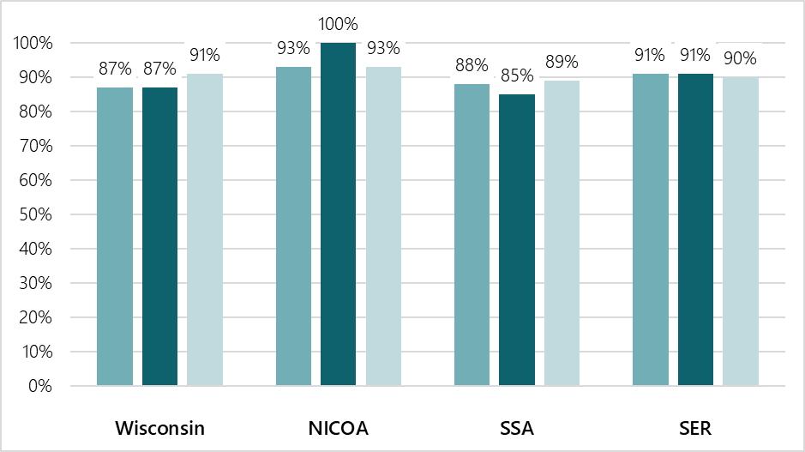

2017

2018

2016

2017

2018

2016

2017

2018

2016

2017

2018

2016

Source: SCSEP Performance and Results Quarterly Progress Report (SPARQ) Data System, 2020

### Are Minorities (20 C.F.R. § 641.325(b)).

Table 18 provides racial and ethnic population estimates for those who are 55 years old and older. Race groups include only non-Hispanics. All those of any race reporting Hispanic/Latino ethnicity are in the Hispanic/Latino column only.

#### Table 18: Population Estimates by Race for 2018

| County | Total 55+ Pop. | Non-Hispanic Totals | | | | | | Hisp./ Latino |
| --- | --- | --- | --- | --- | --- | --- | --- | --- |
| White | Black/ Afr. Amer. | Native Amer. | Asian | Hawaiian | 2+ Races |
| Adams | 9,859 | 9,523 | 68 | 48 | 34 | 1 | 61 | 124 |
| Ashland | 5,522 | 4,925 | 6 | 414 | 21 | 0 | 114 | 42 |
| Barron | 16,944 | 16,511 | 84 | 87 | 59 | 4 | 63 | 136 |
| Bayfield | 7,034 | 6,527 | 13 | 342 | 16 | 1 | 92 | 43 |
| Brown | 73,944 | 68,923 | 585 | 1,208 | 931 | 19 | 317 | 1,961 |
| Buffalo | 5,000 | 4,928 | 5 | 8 | 7 | 0 | 25 | 27 |
| Burnett | 7,264 | 6,916 | 25 | 187 | 17 | 2 | 77 | 40 |
| Calumet | 14,806 | 14,303 | 46 | 53 | 165 | 4 | 61 | 174 |
| Chippewa | 21,042 | 20,571 | 72 | 56 | 143 | 4 | 81 | 115 |
| Clark | 10,566 | 10,323 | 15 | 47 | 23 | 2 | 38 | 118 |
| Columbia | 18,999 | 18,449 | 99 | 71 | 115 | 8 | 68 | 189 |
| Crawford | 6,343 | 6,216 | 28 | 8 | 25 | 4 | 31 | 31 |
| Dane | 137,689 | 126,822 | 3,613 | 195 | 3,533 | 43 | 647 | 2,836 |
| Dodge | 29,047 | 28,172 | 158 | 84 | 99 | 6 | 99 | 429 |
| Door | 13,221 | 12,920 | 38 | 47 | 37 | 5 | 64 | 110 |
| Douglas | 14,814 | 14,215 | 55 | 246 | 46 | 1 | 174 | 77 |
| Dunn | 12,709 | 12,391 | 34 | 46 | 108 | 0 | 51 | 79 |
| Eau Claire | 28,816 | 27,815 | 114 | 114 | 449 | 7 | 113 | 204 |
| Florence | 2,078 | 2,031 | 7 | 15 | 7 | 0 | 9 | 9 |
| Fond du Lac | 34,265 | 33,153 | 123 | 130 | 198 | 6 | 123 | 532 |
| Forest | 3,579 | 3,262 | 4 | 261 | 4 | 4 | 30 | 14 |
| Grant | 15,668 | 15,422 | 59 | 27 | 49 | 3 | 45 | 63 |
| Green | 12,741 | 12,504 | 35 | 27 | 38 | 1 | 33 | 103 |
| Green Lake | 7,262 | 7,049 | 21 | 33 | 15 | 1 | 26 | 117 |
| Iowa | 8,234 | 8,061 | 19 | 15 | 54 | 2 | 34 | 49 |
| Iron | 2,856 | 2,796 | 5 | 15 | 8 | 0 | 22 | 10 |
| Jackson | 6,953 | 6,548 | 31 | 266 | 20 | 3 | 24 | 61 |
| Jefferson | 26,870 | 25,899 | 85 | 69 | 129 | 7 | 104 | 577 |
| Juneau | 9,656 | 9,294 | 58 | 88 | 37 | 2 | 57 | 120 |
| Kenosha | 47,627 | 42,491 | 1,752 | 152 | 570 | 16 | 280 | 2,366 |
| Kewaunee | 7,332 | 7,195 | 23 | 22 | 19 | 6 | 23 | 44 |
| La Crosse | 35,455 | 33,191 | 201 | 107 | 594 | 13 | 122 | 227 |
| Lafayette | 5,750 | 5,659 | 5 | 3 | 18 | 0 | 16 | 49 |
| Langlade | 7,965 | 7,769 | 35 | 54 | 19 | 0 | 51 | 37 |
| Lincoln | 10,905 | 10,707 | 18 | 27 | 39 | 6 | 51 | 57 |
| Manitowoc | 29,129 | 28,306 | 77 | 115 | 289 | 2 | 78 | 262 |
| Marathon | 43,592 | 42,115 | 107 | 134 | 821 | 6 | 120 | 289 |
| Marinette | 16,800 | 16,433 | 25 | 92 | 46 | 4 | 88 | 112 |
| Marquette | 6,647 | 6,465 | 21 | 41 | 33 | 2 | 24 | 61 |
| Menominee | 1,228 | 382 | 2 | 788 | 17 | 0 | 18 | 21 |
| Milwaukee | 243,507 | 169,615 | 49,264 | 1,040 | 5494 | 35 | 1388 | 16,671 |
| Monroe | 14,431 | 13,898 | 118 | 133 | 91 | 7 | 63 | 121 |
| Oconto | 14,362 | 14,029 | 14 | 115 | 52 | 4 | 66 | 82 |
| Oneida | 14,831 | 15,491 | 27 | 82 | 64 | 1 | 107 | 59 |
| Outagamie | 53,253 | 50,581 | 207 | 730 | 728 | 11 | 248 | 748 |
| Ozaukee | 31,393 | 30,126 | 342 | 57 | 379 | 8 | 115 | 366 |
| Pepin | 2,836 | 2,794 | 7 | 7 | 7 | 0 | 11 | 10 |
| Pierce | 12,089 | 11,824 | 33 | 36 | 44 | 0 | 55 | 97 |
| Polk | 16,331 | 16,005 | 29 | 89 | 51 | 2 | 61 | 94 |
| Portage | 21,329 | 20,691 | 40 | 63 | 251 | 2 | 62 | 220 |
| Price | 5,989 | 5,847 | 13 | 29 | 19 | 5 | 33 | 43 |
| Racine | 61,103 | 52,669 | 4,222 | 197 | 506 | 15 | 300 | 3,194 |
| Richland | 6,742 | 6,616 | 23 | 16 | 20 | 2 | 20 | 45 |
| Rock | 49,857 | 46,328 | 1,552 | 121 | 395 | 7 | 212 | 1,242 |
| Rusk | 5,890 | 5,758 | 19 | 27 | 9 | 0 | 43 | 34 |
| St. Croix | 25,325 | 24,695 | 102 | 87 | 127 | 8 | 83 | 223 |
| Sauk | 21,133 | 20,530 | 70 | 126 | 86 | 3 | 74 | 244 |
| Sawyer | 7,321 | 6,526 | 7 | 598 | 12 | 0 | 134 | 44 |
| Shawano | 15,066 | 14,048 | 22 | 710 | 59 | 3 | 112 | 112 |
| Sheboygan | 37,841 | 36,123 | 173 | 98 | 612 | 3 | 86 | 746 |
| Taylor | 7,261 | 7,139 | 6 | 21 | 17 | 3 | 24 | 51 |
| Trempealeau | 9,513 | 9,303 | 15 | 14 | 25 | 2 | 17 | 137 |
| Vernon | 10,798 | 10,636 | 23 | 17 | 18 | 4 | 35 | 65 |
| Vilas | 10,888 | 10,250 | 10 | 470 | 33 | 0 | 54 | 71 |
| Walworth | 33,575 | 31,847 | 150 | 65 | 197 | 7 | 123 | 1,186 |
| Washburn | 7,088 | 6,857 | 4 | 82 | 20 | 1 | 79 | 45 |
| Washington | 45,356 | 44,102 | 287 | 110 | 252 | 13 | 118 | 474 |
| Waukesha | 137,852 | 130,882 | 1,129 | 159 | 2,650 | 37 | 425 | 2,570 |
| Waupaca | 19,122 | 18,694 | 37 | 77 | 53 | 3 | 73 | 185 |
| Waushara | 10,198 | 9,868 | 45 | 33 | 27 | 2 | 48 | 175 |
| Winnebago | 51,032 | 49,069 | 307 | 241 | 556 | 10 | 191 | 658 |
| Wood | 26,527 | 25,764 | 106 | 137 | 214 | 4 | 71 | 231 |
| Wisconsin | 1,806,050 | 1,655,787 | 66,174 | 11,529 | 21,920 | 397 | 8,085 | 42,158 |

Source: U.S. Census, Population Ages 55 and Older Race and Ethnicity, July 2018

### Are Limited English Proficient

Limited English proficiency means a participant who does not speak English as his or her primary language and who has a limited ability to read, speak, write, or understand English. Low literacy skills mean a participant who calculates or solves problems, reads, writes, or speaks at or below an eighth grade level, or who is unable to compute or solve problems, read, write, or speak at a level necessary to function on the job, in the participant’s family, or in society. Table 19 shows the share of the 65+ population in each county that has limited English proficiency.

#### Table 19: Limited English Proficiency Rate per County, Age 65+

| County | Share of 65+ Population with Limited English Proficiency | County | Share of 65+ Population with Limited English Proficiency |
| --- | --- | --- | --- |
| Adams | 1.42% | Marathon | 1.8% |
| Ashland | 0% | Marinette | 0.7% |
| Barron | 0.9% | Marquette | 0.1% |
| Bayfield | 0.1% | Menominee | 4.2% |
| Brown | 1.9% | Milwaukee | 5.8% |
| Buffalo | 0.3% | Monroe | 1.4% |
| Burnett | 0.3% | Oconto | 0.8% |
| Calumet | 0.8% | Oneida | 0.6% |
| Chippewa | 0.1% | Outagamie | 1.8% |
| Clark | 1.4% | Ozaukee | 1.6% |
| Columbia | 0.6% | Pepin | 0.8% |
| Crawford | 0.2% | Pierce | 0.8% |
| Dane | 2.5% | Polk | 0.4% |
| Dodge | 0.7% | Portage | 1.5% |
| Door | 0.7% | Price | 0.2% |
| Douglas | 0.5% | Racine | 2.7% |
| Dunn | 0.6% | Richland | 0.8% |
| Eau Claire | 1.1% | Rock | 1.5% |
| Florence | 0.7% | Rusk | 1.0% |
| Fond du Lac | 0.8% | St. Croix | 0.4% |
| Forest | 0.6% | Sauk | 0.9% |
| Grant | 0.5% | Sawyer | 0.5% |
| Green | 0.5% | Shawano | 0.5% |
| Green Lake | 0.5% | Sheboygan | 2.3% |
| Iowa | 0.7% | Taylor | 0.7% |
| Iron | 0.9% | Trempealeau | 0.4% |
| Jackson | 0.9% | Vernon | 0.3% |
| Jefferson | 0.7% | Vilas | 0.6% |
| Juneau | 1.7% | Walworth | 2.8% |
| Kewaunee | 0.2% | Washington | 0.9% |
| La Crosse | 1.5% | Waukesha | 2.1.% |
| Lafayette | 0.3% | Waupaca | 0.5% |
| Langlade | 0.5% | Waushara | 0.7% |
| Lincoln | 0.0% | Winnebago | 1.1% |
| Manitowoc | 0.7% | Wood | 0.8% |

Source: U.S. Census, 2013-2018 American Community Survey

Grantees work closely with limited-English speaking people to ensure communication methods are in place. Interpretation and translation services are obtained through the county job center at no cost to the participant. Written documents in Spanish and other languages are available for non-English speaking participants.

Table 20 shows the number and percentage of individuals served who are identified as having either limited English proficiency or low literacy skills.

#### Table 20: Share of Positions with Limited English Proficiency or Low Literacy Skills, 2016–2018

| Program Year | Grantee | Authorized Positions | Number with Limited English Proficiency | Percent with Limited English Proficiency |
| --- | --- | --- | --- | --- |
| 2016 | Wisconsin | 228 | 7 | 2% |
| NICOA | 19 | 0 | 0% |
| SSA | 251 | 8 | 2% |
| SER | 613 | 30 | 5% |

| Program Year | Grantee | Authorized Positions | Number with Limited English Proficiency | Percent with Limited English Proficiency |
| --- | --- | --- | --- | --- |
| 2017 | Wisconsin | 209 | 7 | 2% |
| NICOA | 17 | 0 | 0% |
| SSA | 230 | 6 | 1% |
| SER | 560 | 30 | 4% |
| 2018 | Wisconsin | 209 | 7 | 2% |
| NICOA | 17 | 0 | 0% |
| SSA | 231 | 5 | 1% |
| SER | 562 | 39 | 5% |

Source: SPARQ, Quarter 2, PY 2019, U.S. Department of Labor, 2020

### Have the greatest social need (20 C.F.R. § 641.325(b)).

A participant is considered to have great social need at enrollment by having little or no employment history, no basic skills, and little to no high school education, as well as being English-language deficient, disabled, homeless, or living in a socially or economically isolated area where there are limited employment opportunities.

Table 21 shows the percent of individuals who were served by SCSEP whose prospects for employment were low (or poor).

#### Table 21: People Served with Poor or Low Employment Prospects, 2016–2016

| Program Year | Grantee | Authorized Positions | End of Year Number | End of Year to Date % |
| --- | --- | --- | --- | --- |
| 2016 | Wisconsin | 228 | 307 | 91% |
| NICOA | 19 | 19 | 70% |
| SSA | 251 | 421 | 95% |
| SER | 613 | 625 | 100% |
| 2017 | Wisconsin | 209 | 311 | 93% |
| NICOA | 17 | 13 | 87% |
| SSA | 230 | 397 | 94% |
| SER | 560 | 736 | 98% |
| 2018 | Wisconsin | 209 | 293 | 98% |
| NICOA | 17 | 22 | 81% |
| SSA | 231 | 428 | 96% |
| SER | 562 | 766 | 99% |

Source: SPARQ, U.S. Department of Labor, Quarterly Progress Reports, 2020

## Steps Taken to Avoid Service Disruptions

Describe the steps taken to avoid disruptions to service for participants to the greatest extent possible, when positions are redistributed, as provided in 20 C.F.R. § 641.365; when new census or other reliable data becomes available; or when there is over-enrollment for any other reason (20 C.F.R. §§ 641.325(i), 641.302(b)).

SCSEP national grantees and the Bureau of Aging and Disability Resources (BADR) work together to ensure that people who want to work have the opportunity to do so through the services of the program. The Department of Labor provides the distribution factor based on current census data. The distribution factor is the current formula for defining the equitable share of SCSEP positions for each county, based on the proportion of income and age-eligible population by county annually. BADR determines annually which counties are over- or underserved and calculates the movement of positions in order to distribute them equitably. The calculations are sent to the national grantees for review and comment prior to approval. BADR then sends the equitable distribution report to the Department of Labor. Through their collaboration, BADR and the national grantees have traditionally been successful in ensuring there is either no or minimal disruption of service to participants.

# Appendices

* Appendix A: State and National Authorized Positions
* Appendix B: Workforce Development Boards and Areas
* Appendix C: Aging and Disability Resource Centers
* Appendix D: State Plan Meeting and Attestation of Plan Participation
* Appendix E: National Grantee Comments
* Appendix F: Public Comments

## Appendix A: State and National Authorized Positions

### State Authorized Positions (210), Listed by Subrecipient

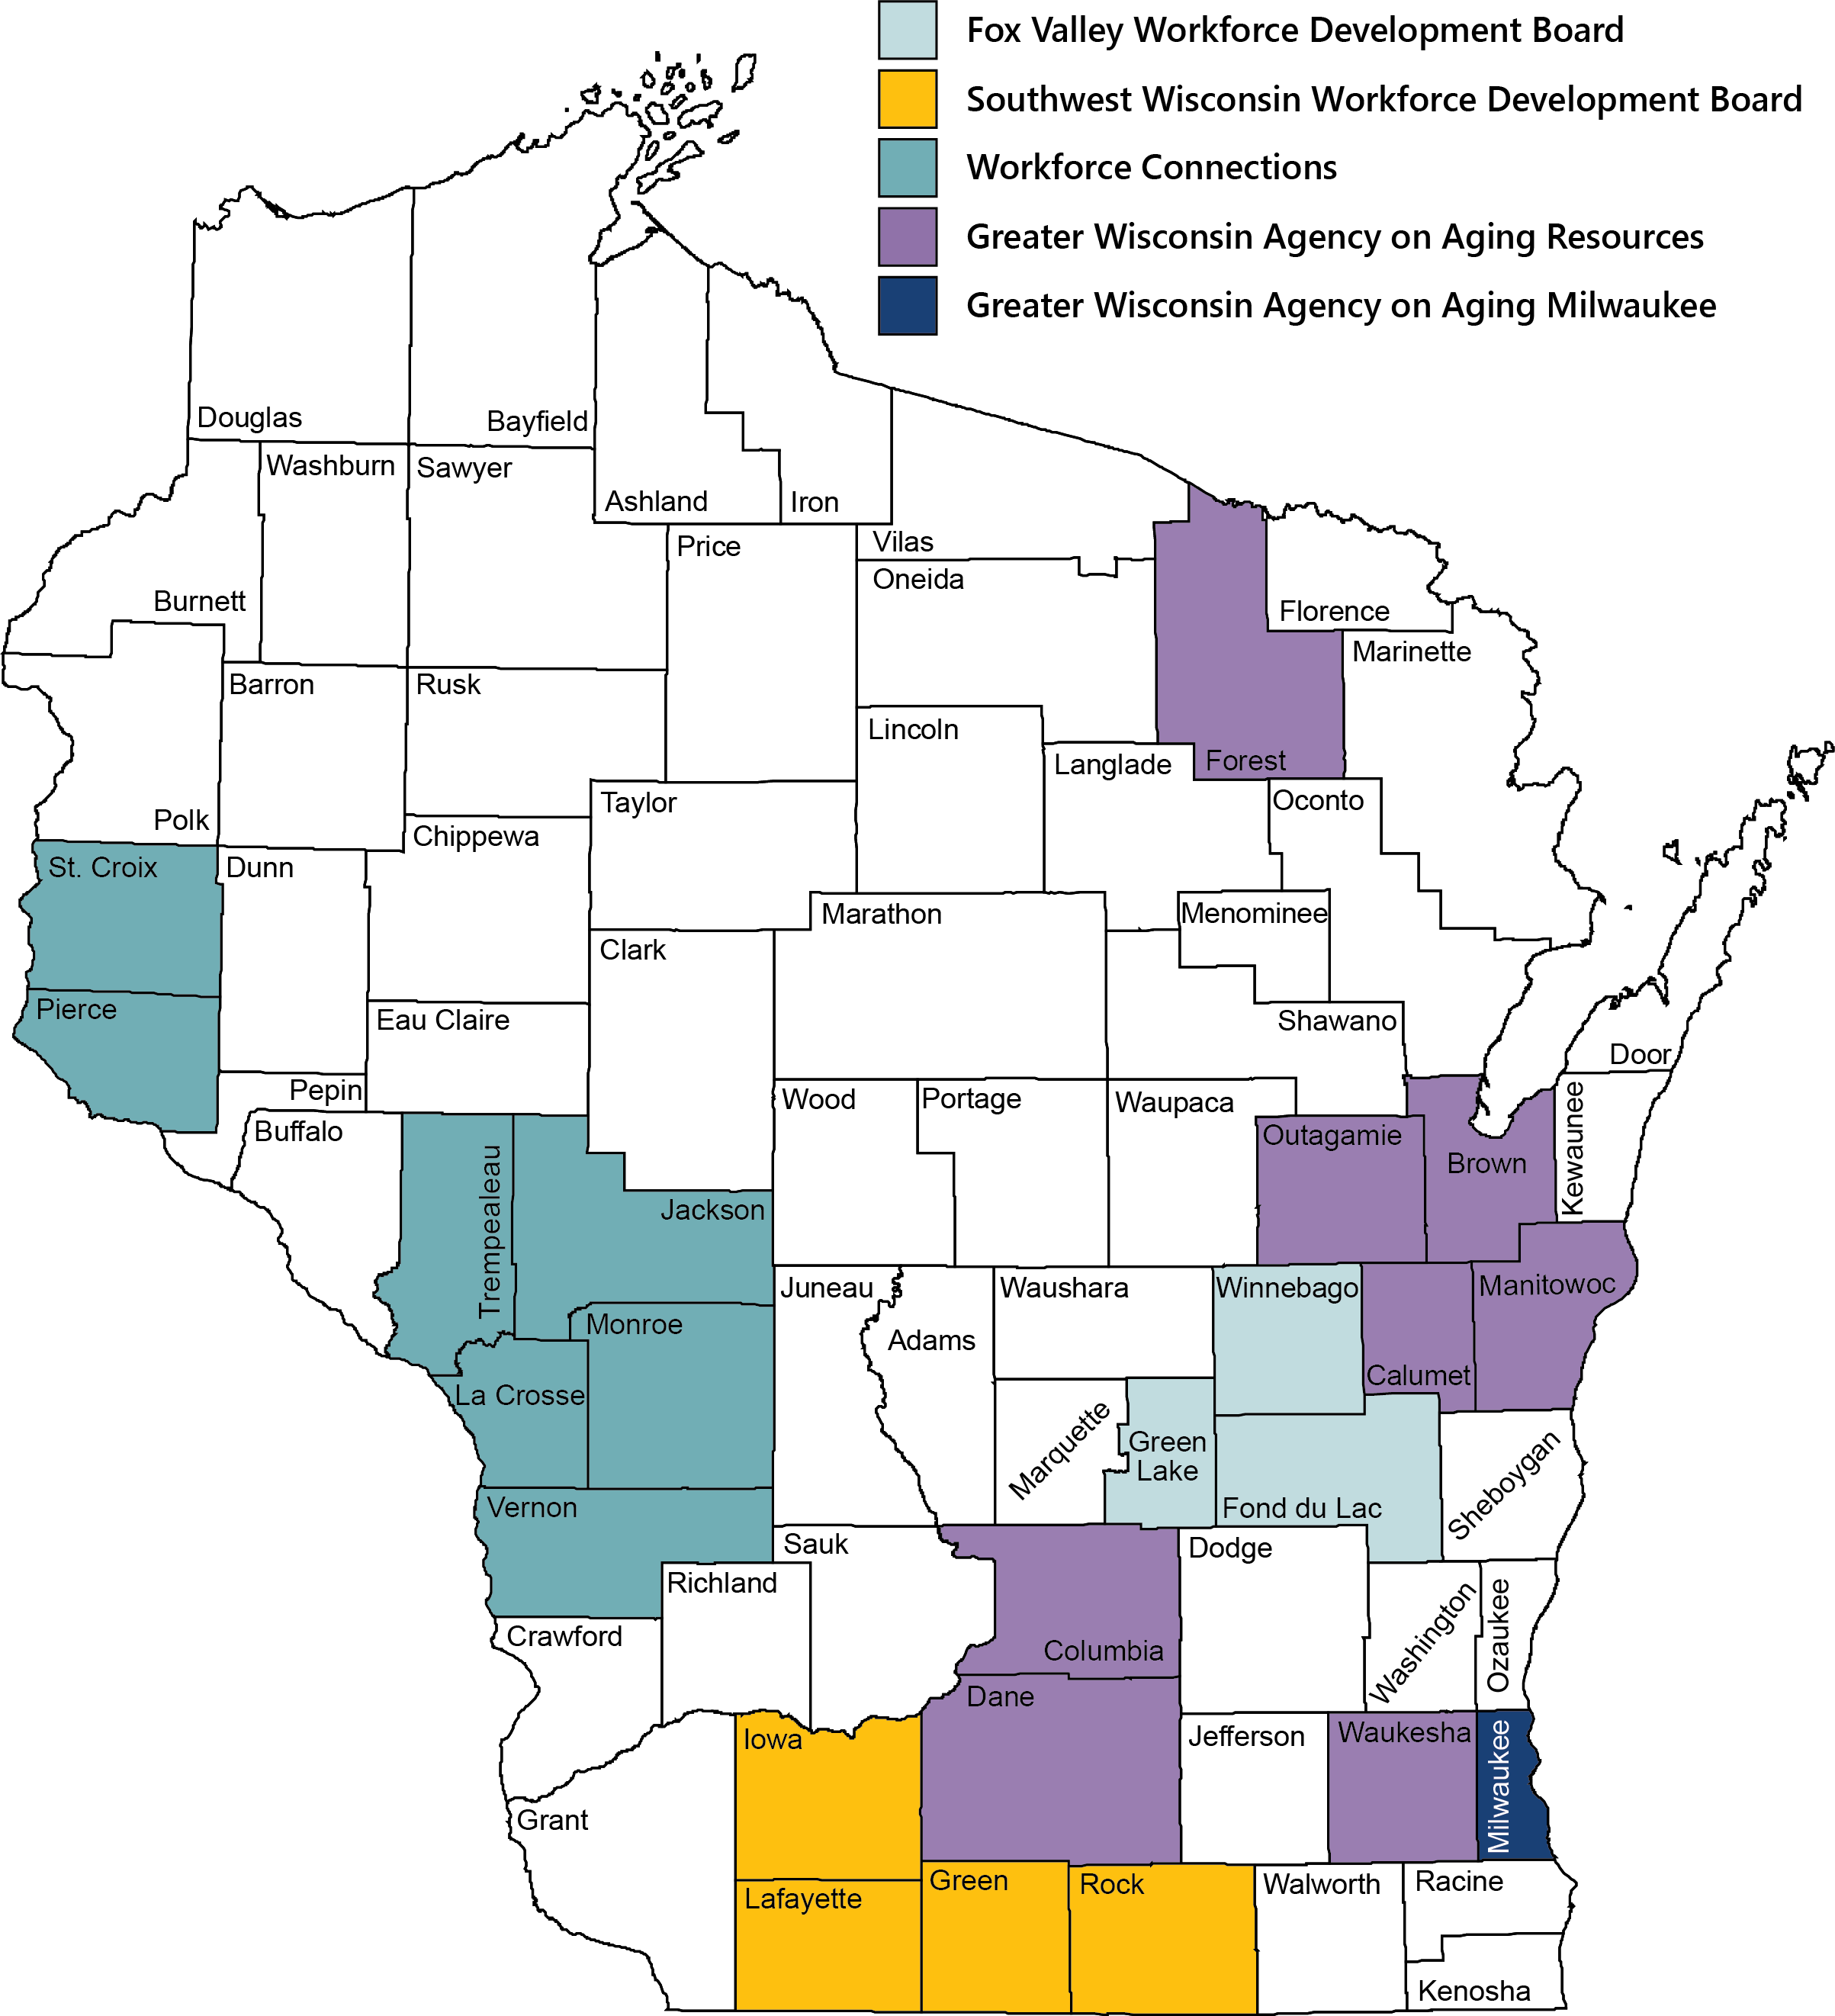

### National Authorized Positions (811), Listed by Grantee and Subrecipient

As of March 2020, only Senior Service America, Inc. (SSA) had returned the state’s request for a coverage map. Other national grantees and subrecipients cannot be confirmed.

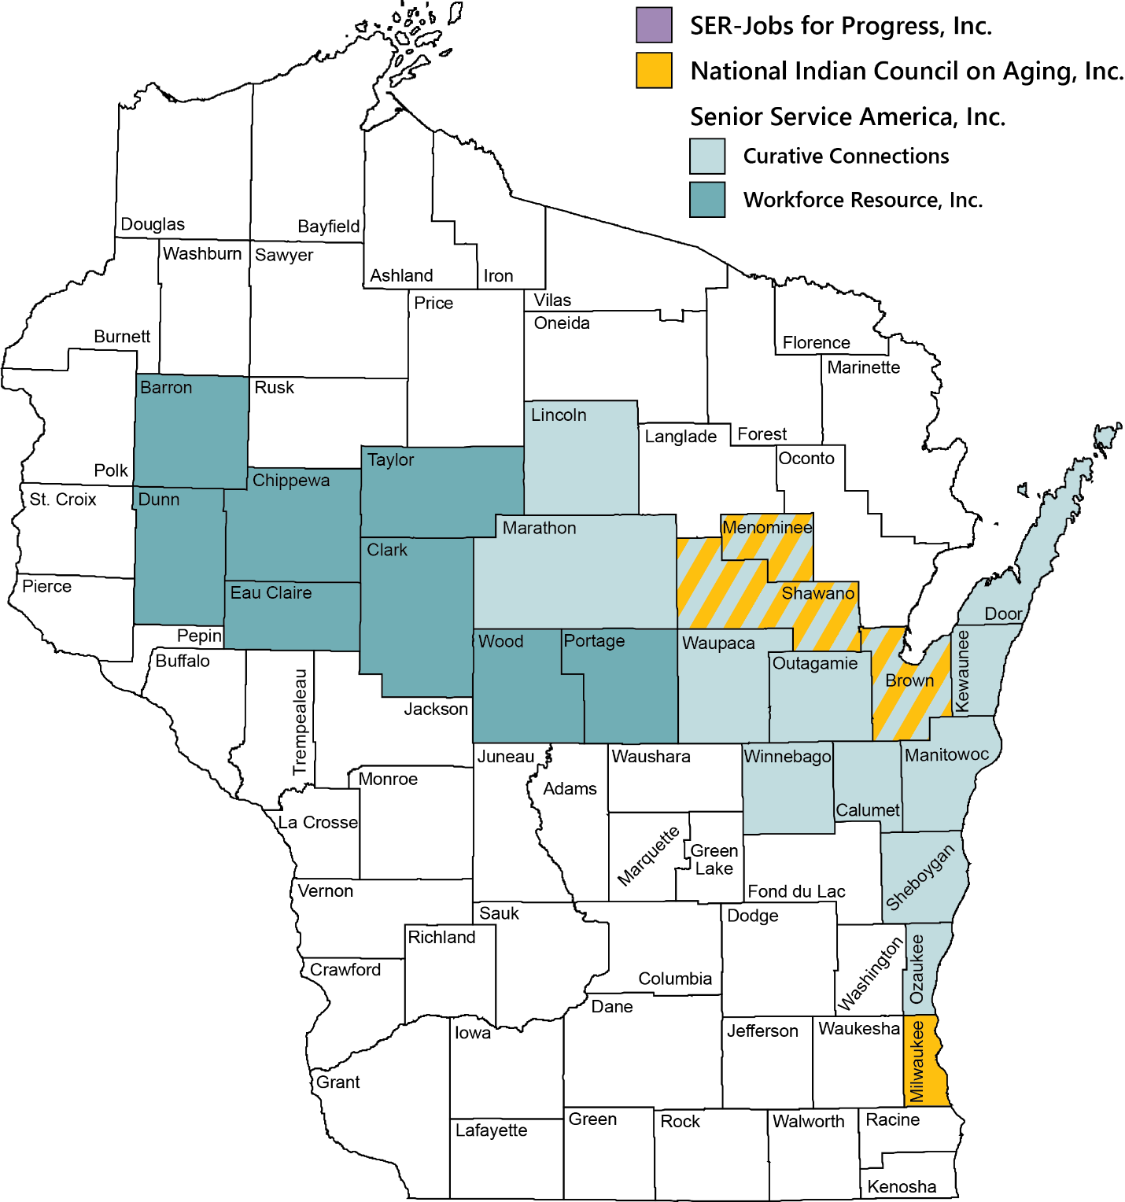

## Appendix B: Wisconsin Workforce Development Boards and Areas

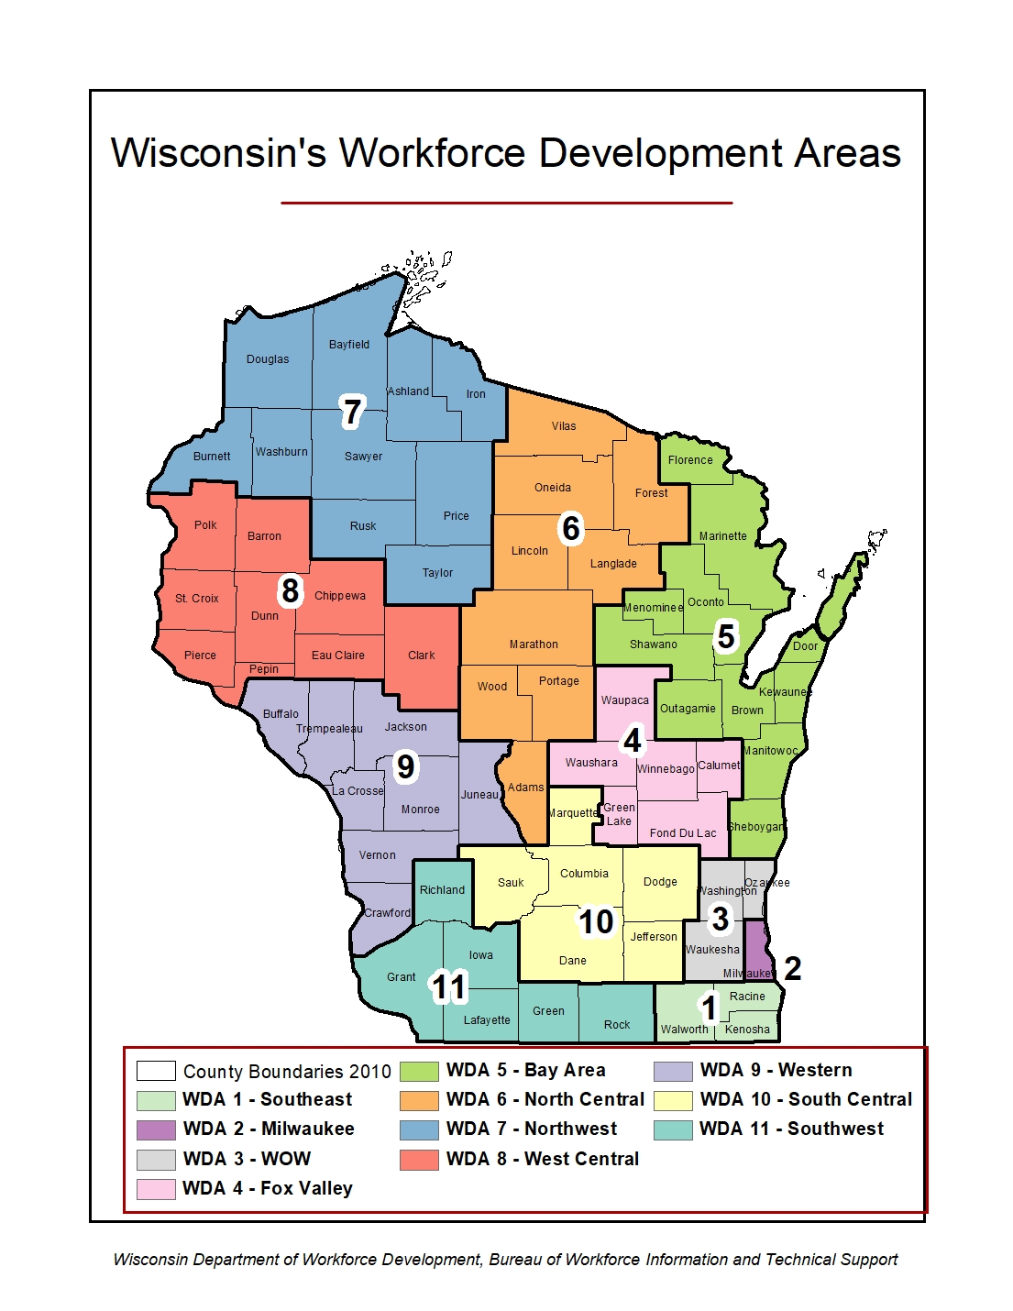

Source: Wisconsin Department of Workforce Development, Bureau of Workforce Information and Technical Support

## Appendix C: Wisconsin’s Aging and Disability Resource Centers

### Aging and Disability Resource Center (ADRC) Coverage Areas

### Wisconsin Counties where ADRCs and Aging Units are Combined

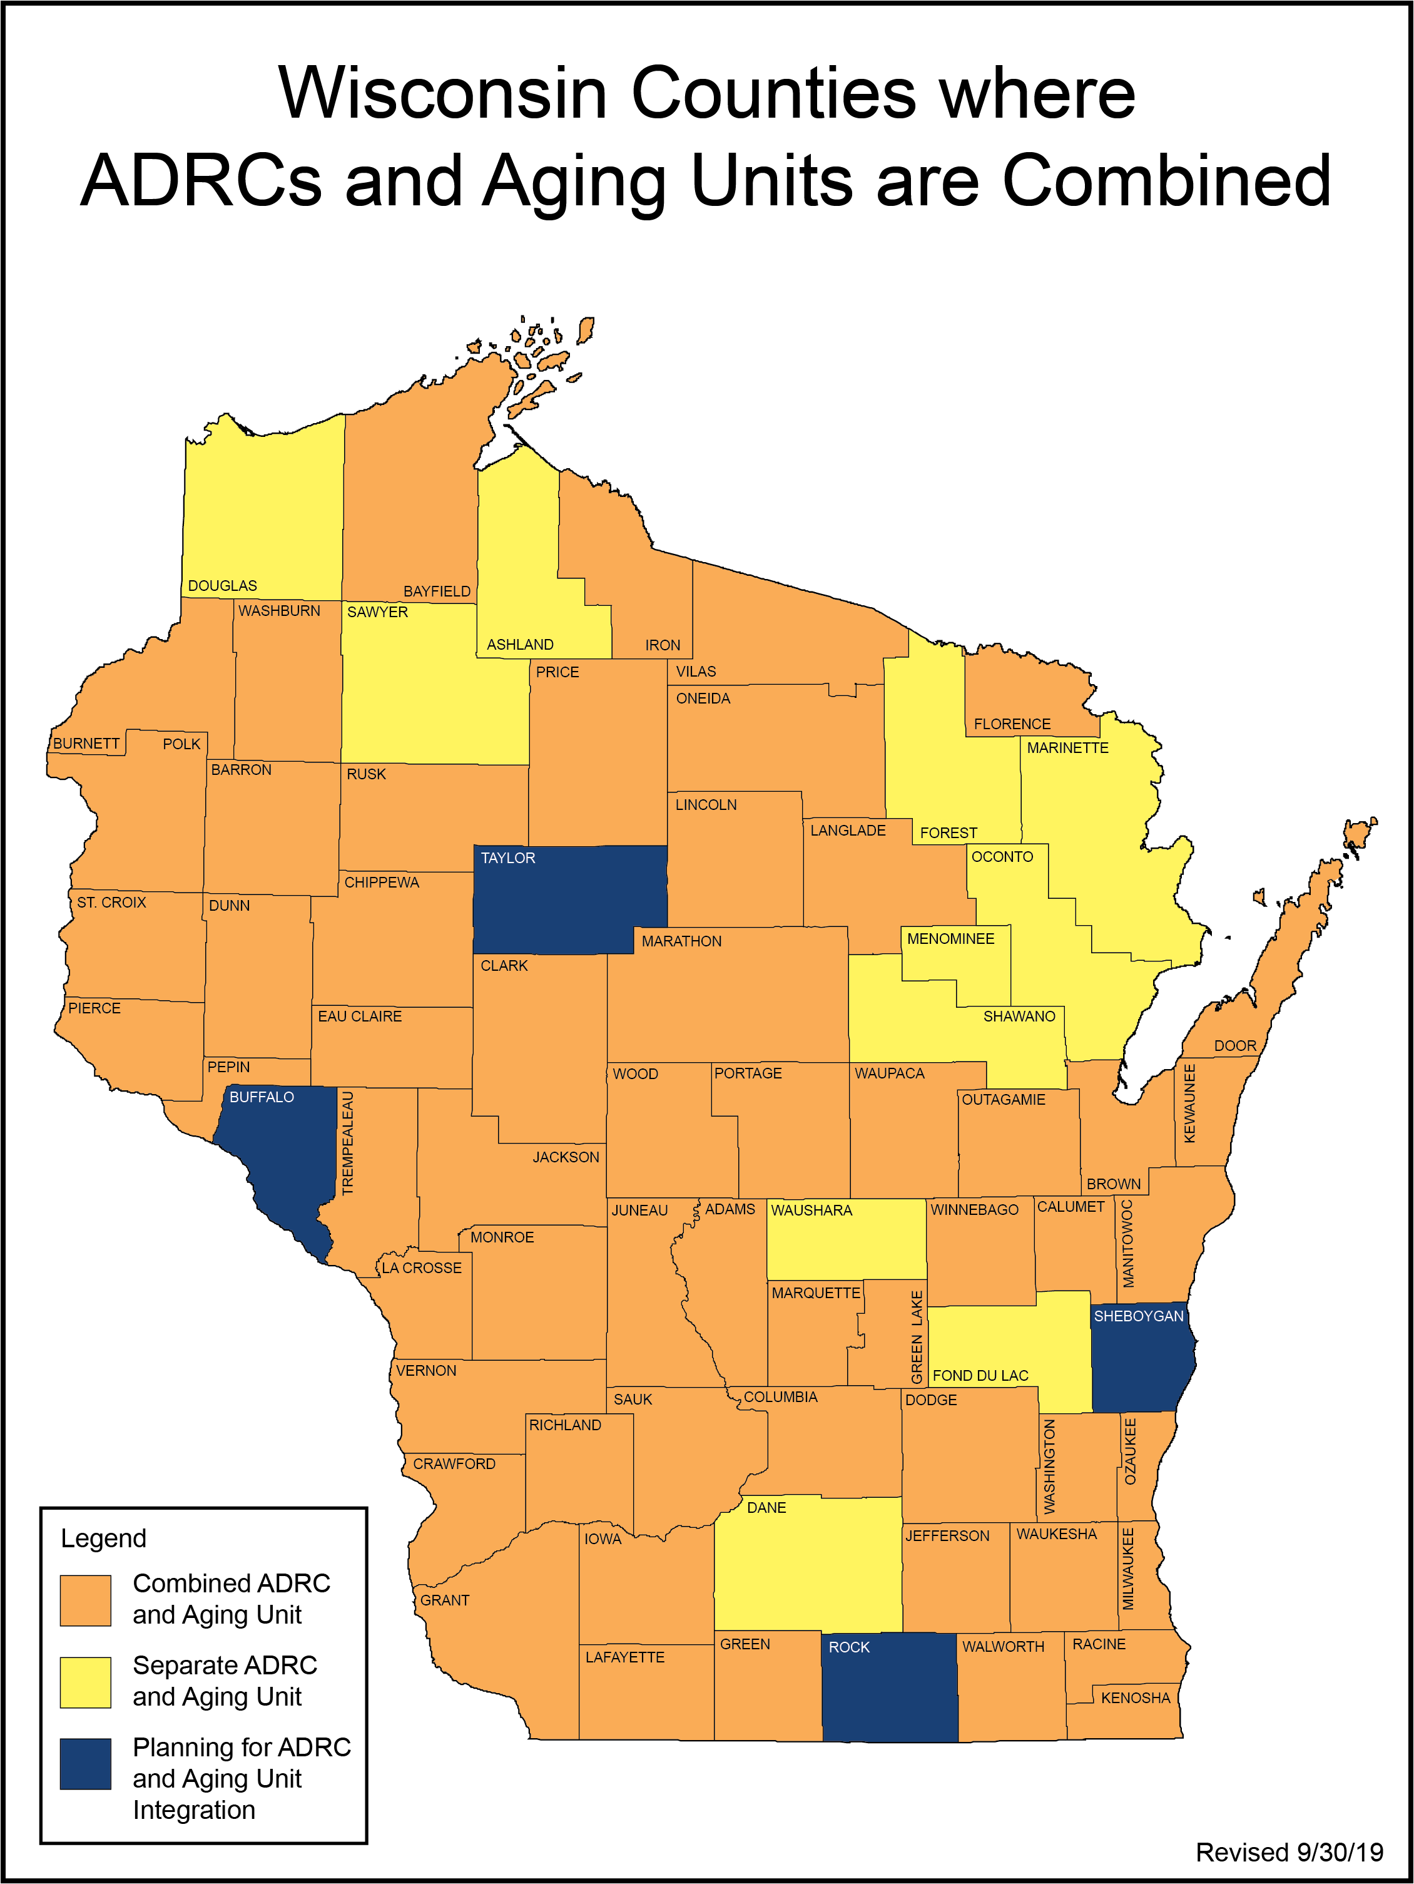

## Appendix D: Wisconsin State Strategic Plan 2020-2023 Meeting Notice

The Older Americans Act of 2006, Section 503, mandates a four-year strategy for the statewide provision of community service employment and other authorized activities for eligible individuals in the SCSEP program. The four-year plan is intended to foster both short-term and long-term coordination among national and state sub grantees operating the SCSEP to facilitate the efforts of key stakeholders to work collaboratively in order to accomplish programs goals. In addition, this plan emphasizes the importance of partnership among grantees and other programs.

The Department of Health Services, Bureau of Aging and Disability Resources is responsible for implementation of the SCSEP State Plan along with input from national grantees. The four-year plan takes a longer-term view of the SCSEP program.

A State Plan meeting will be held with national and state subrecipients to discuss economic projections and impact, service delivery and coordination, and location and populations served using the Equitable Distribution Report. Much of the information in this plan contains revised census and SPARQ data. To facilitate review of the draft plan a meeting is scheduled for Thursday, February 20th, 2020, from 9:00 a.m. to 12:00 p.m. at Greater Wisconsin Agency on Aging Resources, Inc. (GWAAR) 1414 MacArthur Rd., Suite A, Madison, Wisconsin.

For questions or concerns, call Laura Langer, Wisconsin Senior Employment Program Coordinator with the Bureau of Aging and Disability Resources at (608) 267-9097.

Wisconsin Senior Community Services Employment Program   
State Plan PY 2020-2023   
Open Meeting Notice

Thursday, February 20th, 2020, 9:00 a.m.–12:00 p.m.  
Greater Wisconsin Agency on Aging Resources, Inc.  
1414 MacArthur Rd., Madison

AGENDA

1. Welcome, Introductions and Purpose
2. Equitable Distribution Report: Under- and Over-Served Counties Discussion
3. Challenges Serving Rural and Urban Areas
4. Collaborations with Job Centers, Marketing and Recruitment Techniques
5. Questions and Public Comment (11:45 a.m. – 12:00 p.m.)
6. Adjourn

The purpose of this meeting is to conduct the governmental business outlined in the above agenda and is administratively attached to the Department of Health Services. If you need an interpreter, alternate formats, or other accommodations to participate, please contact Laura Langer at 608-267-9097 or laura.langer@dhs.wisconsin.gov.

Conference Call: 1-877-820-7831 Passcode: 725384

Meeting Invitees: Those noted in Bold attended in person or by conference call.

* Deb Buckley, Curative Connections, Inc, Green Bay (SSA)
* Jane Budde, Worksmart Network, Madison
* Dave Chapman, Greater Wisconsin Agency on Aging Resources, Inc., Madison
* Sue Chapman, National Indian Council on Aging, Inc., Albuquerque, N.M.
* Julie Enloe, Employment & Training Association, Madison
* Don Gatewood, Senior Service America, Inc., Silver Spring, MD
* Darice Hannon, Greater Wisconsin Agency on Aging Resources, Inc., Green Bay
* Laura Langer, Wisconsin Office on Aging, SCSEP Administrator
* Harold Luther, Southwest Workforce Development Board, Inc., Janesville
* Neal Minogue, Wisconsin Office on Aging
* Alma Ramirez, Greater Wisconsin Agency on Aging Resources, Inc., Madison
* Carrie Schnieder, Wisconsin Department of Workforce Development
* Michaela Stendahl, Workforce Resources, Inc (SSA)
* Emma Trevino, SER- Jobs for Progress

## Appendix E: National Grantee Comments

## Appendix F: Public Comments