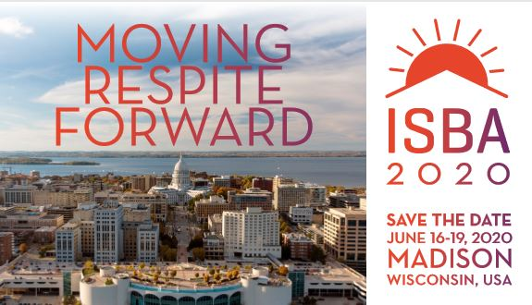

Monona Terrace Convention Center | Madison, WI
Register now at www.isba.me/registration
Early bird registration ends March 1, 2020!
ARCH will be sponsoring a Respite Research Summit following the Conference on June 19, 2020. Read more at archrespite.org/respite-research#Summit

The ARCH National Respite Network and Resource Center is proud to host the International Short Break Conference with the International Short Break Association, the University of Wiconsin Madison School of Nursing and the Respite Care Assocation of Wisconsin.


For more information, visit the conference website www.isba.me or email isba2020@union.wisc.edu

