
When I become upset, I can choose to:

- Count to ten 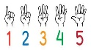 or

- Take 3 deep breaths 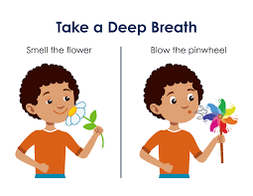 or

- Go to a calming spot 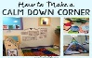

Once I have calmed down, I can continue with my day.

